We will be using Stripe Payment gateway and Paypal. - OK. NO PROBLEM

This is just a rough draft and are not the final. Majority of the functions are here with exceptions to some of them that I have written in yellow.

I want to get your feedback before I can fully complete these documents.

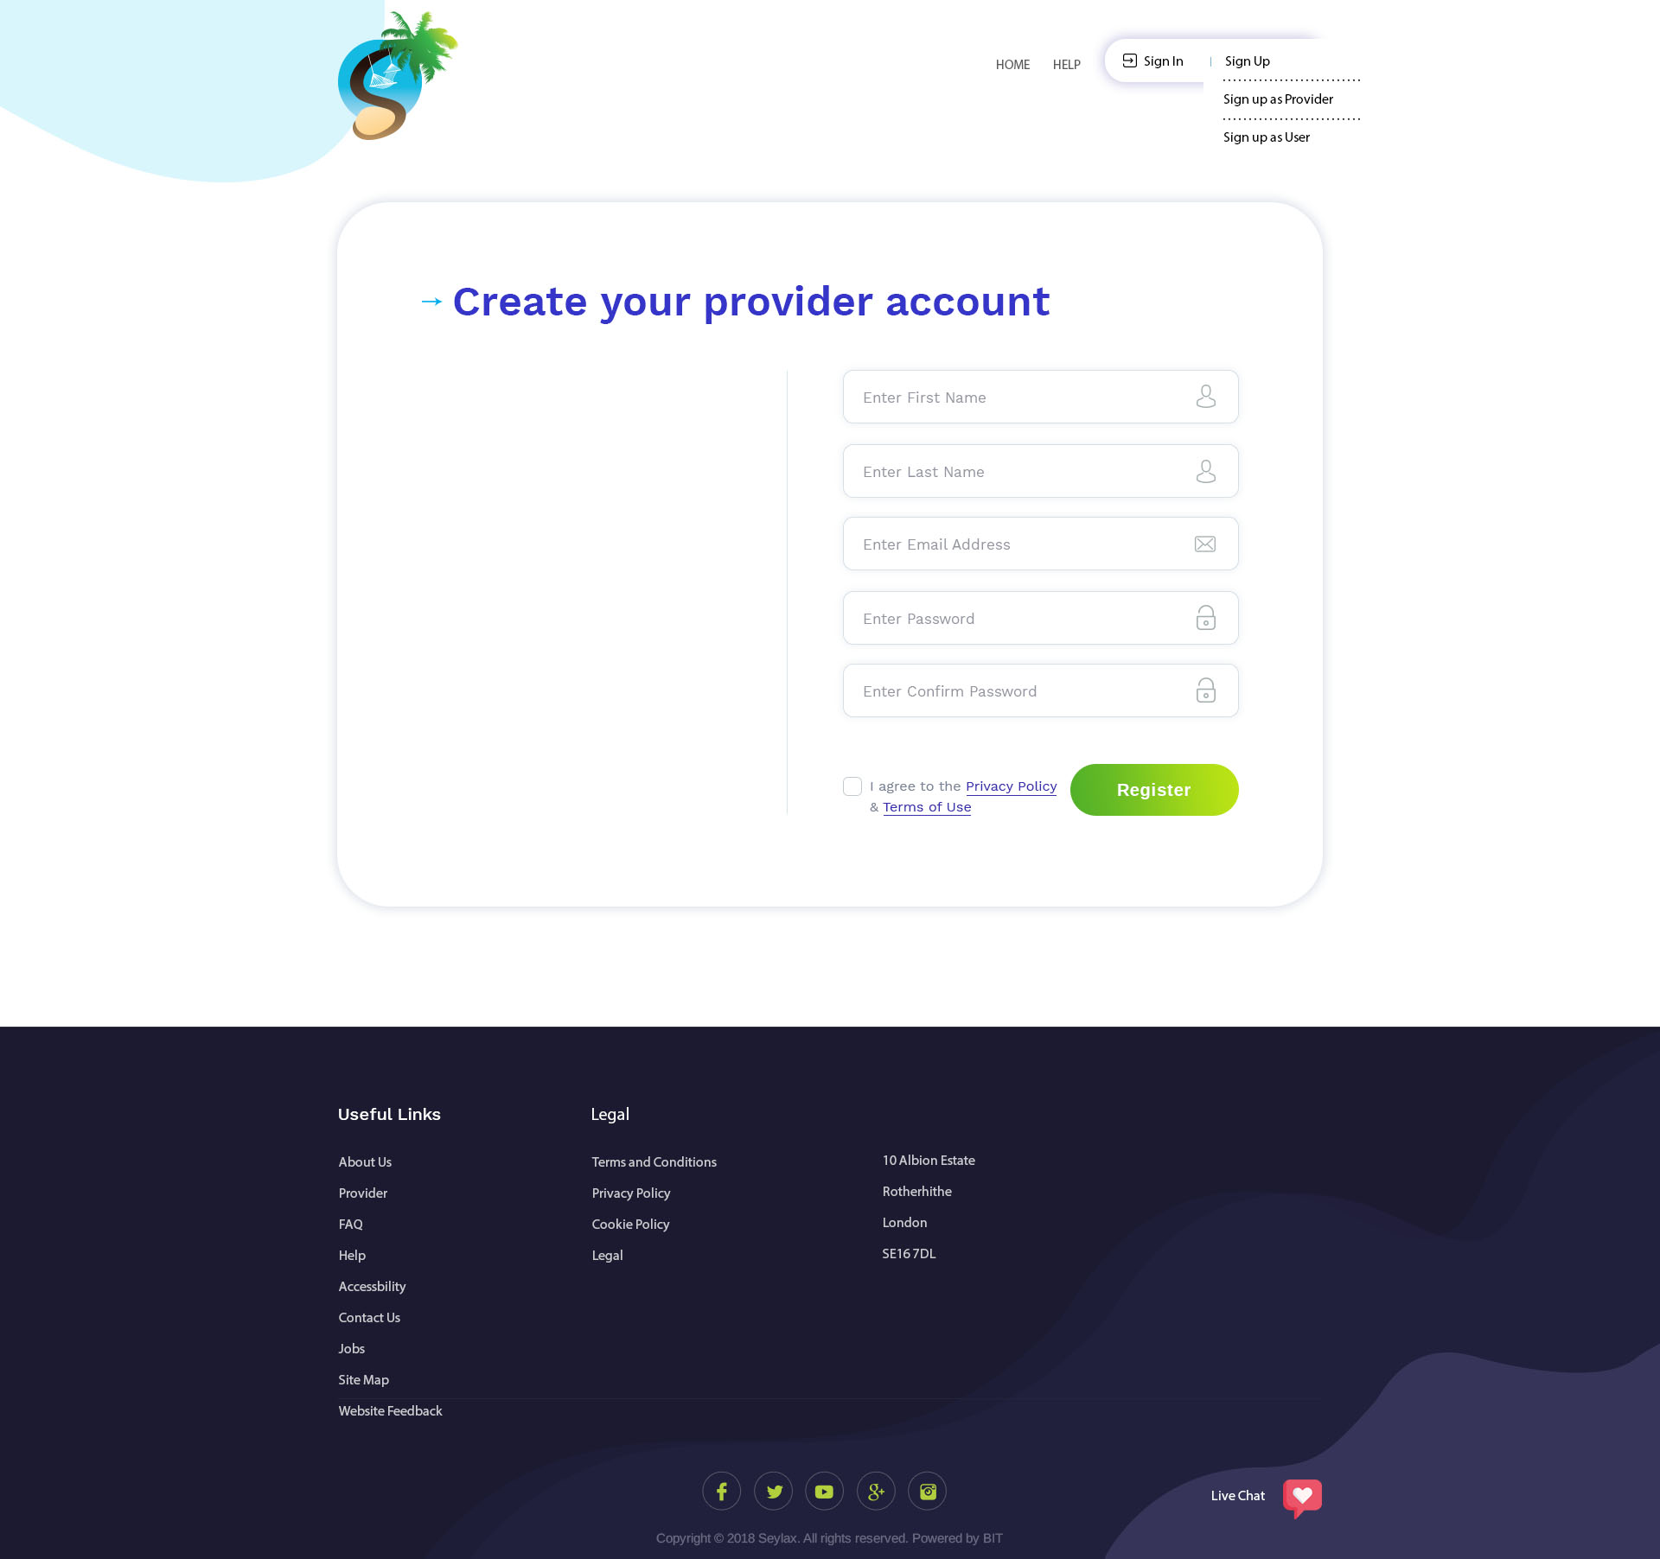

This is the page where provider can sign up. They will create their account through here. We also have terms & conditions and privacy policy.

After they have entered their credentials and click on Register, it will take them to page 2. OK

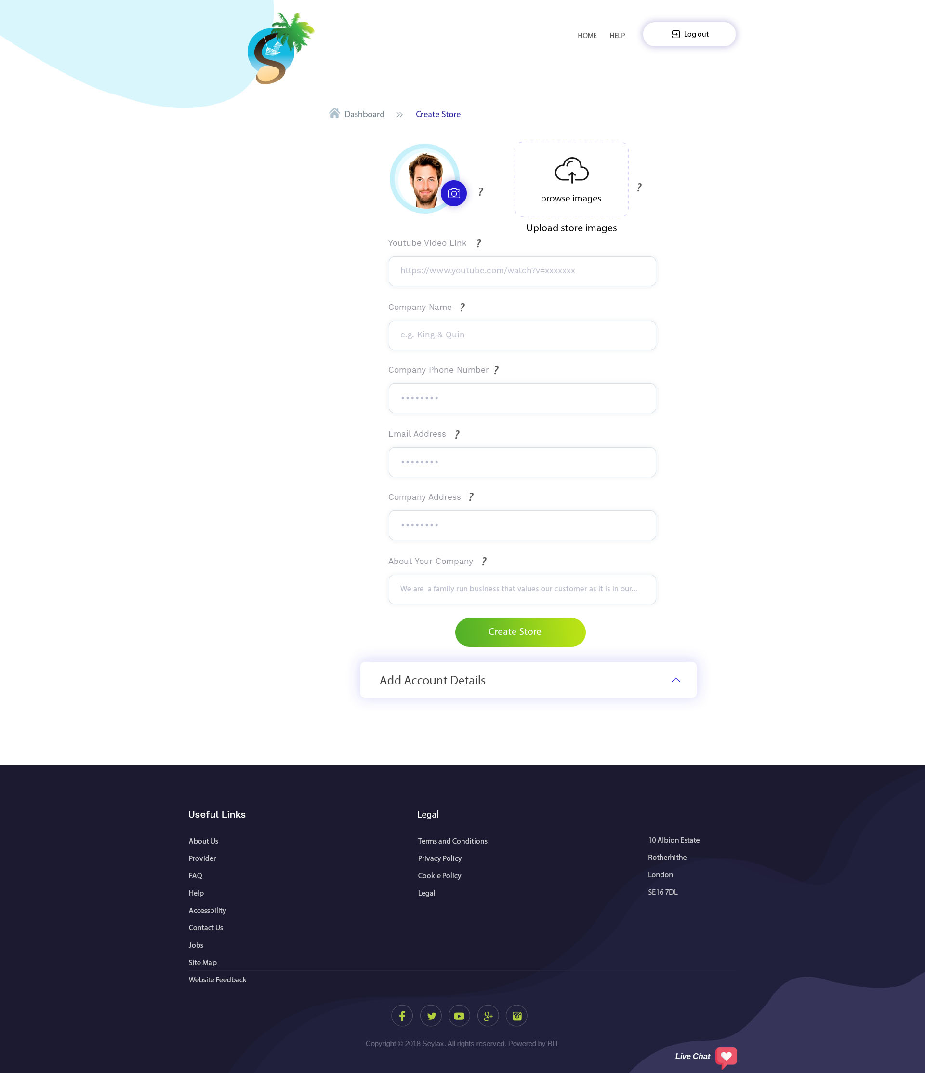

This page will allow them to enter the information about their company. It will also allow them to add a profile picture and upload up to 6 pictures of their store/company.

YouTube link would allow them to enter embed YouTube link to their store.

After they have clicked on create store, a pop up message will give them the option to add in their bank information now or at a later time. ‘Add Account Details’ will open and this is where they will be entering their credentials (page 4).

‘About Your Company’ should allow them to write up to 90 words. I will make the field bigger. OK

? next to the field for a pop up window when hovered over explaining the function. OK

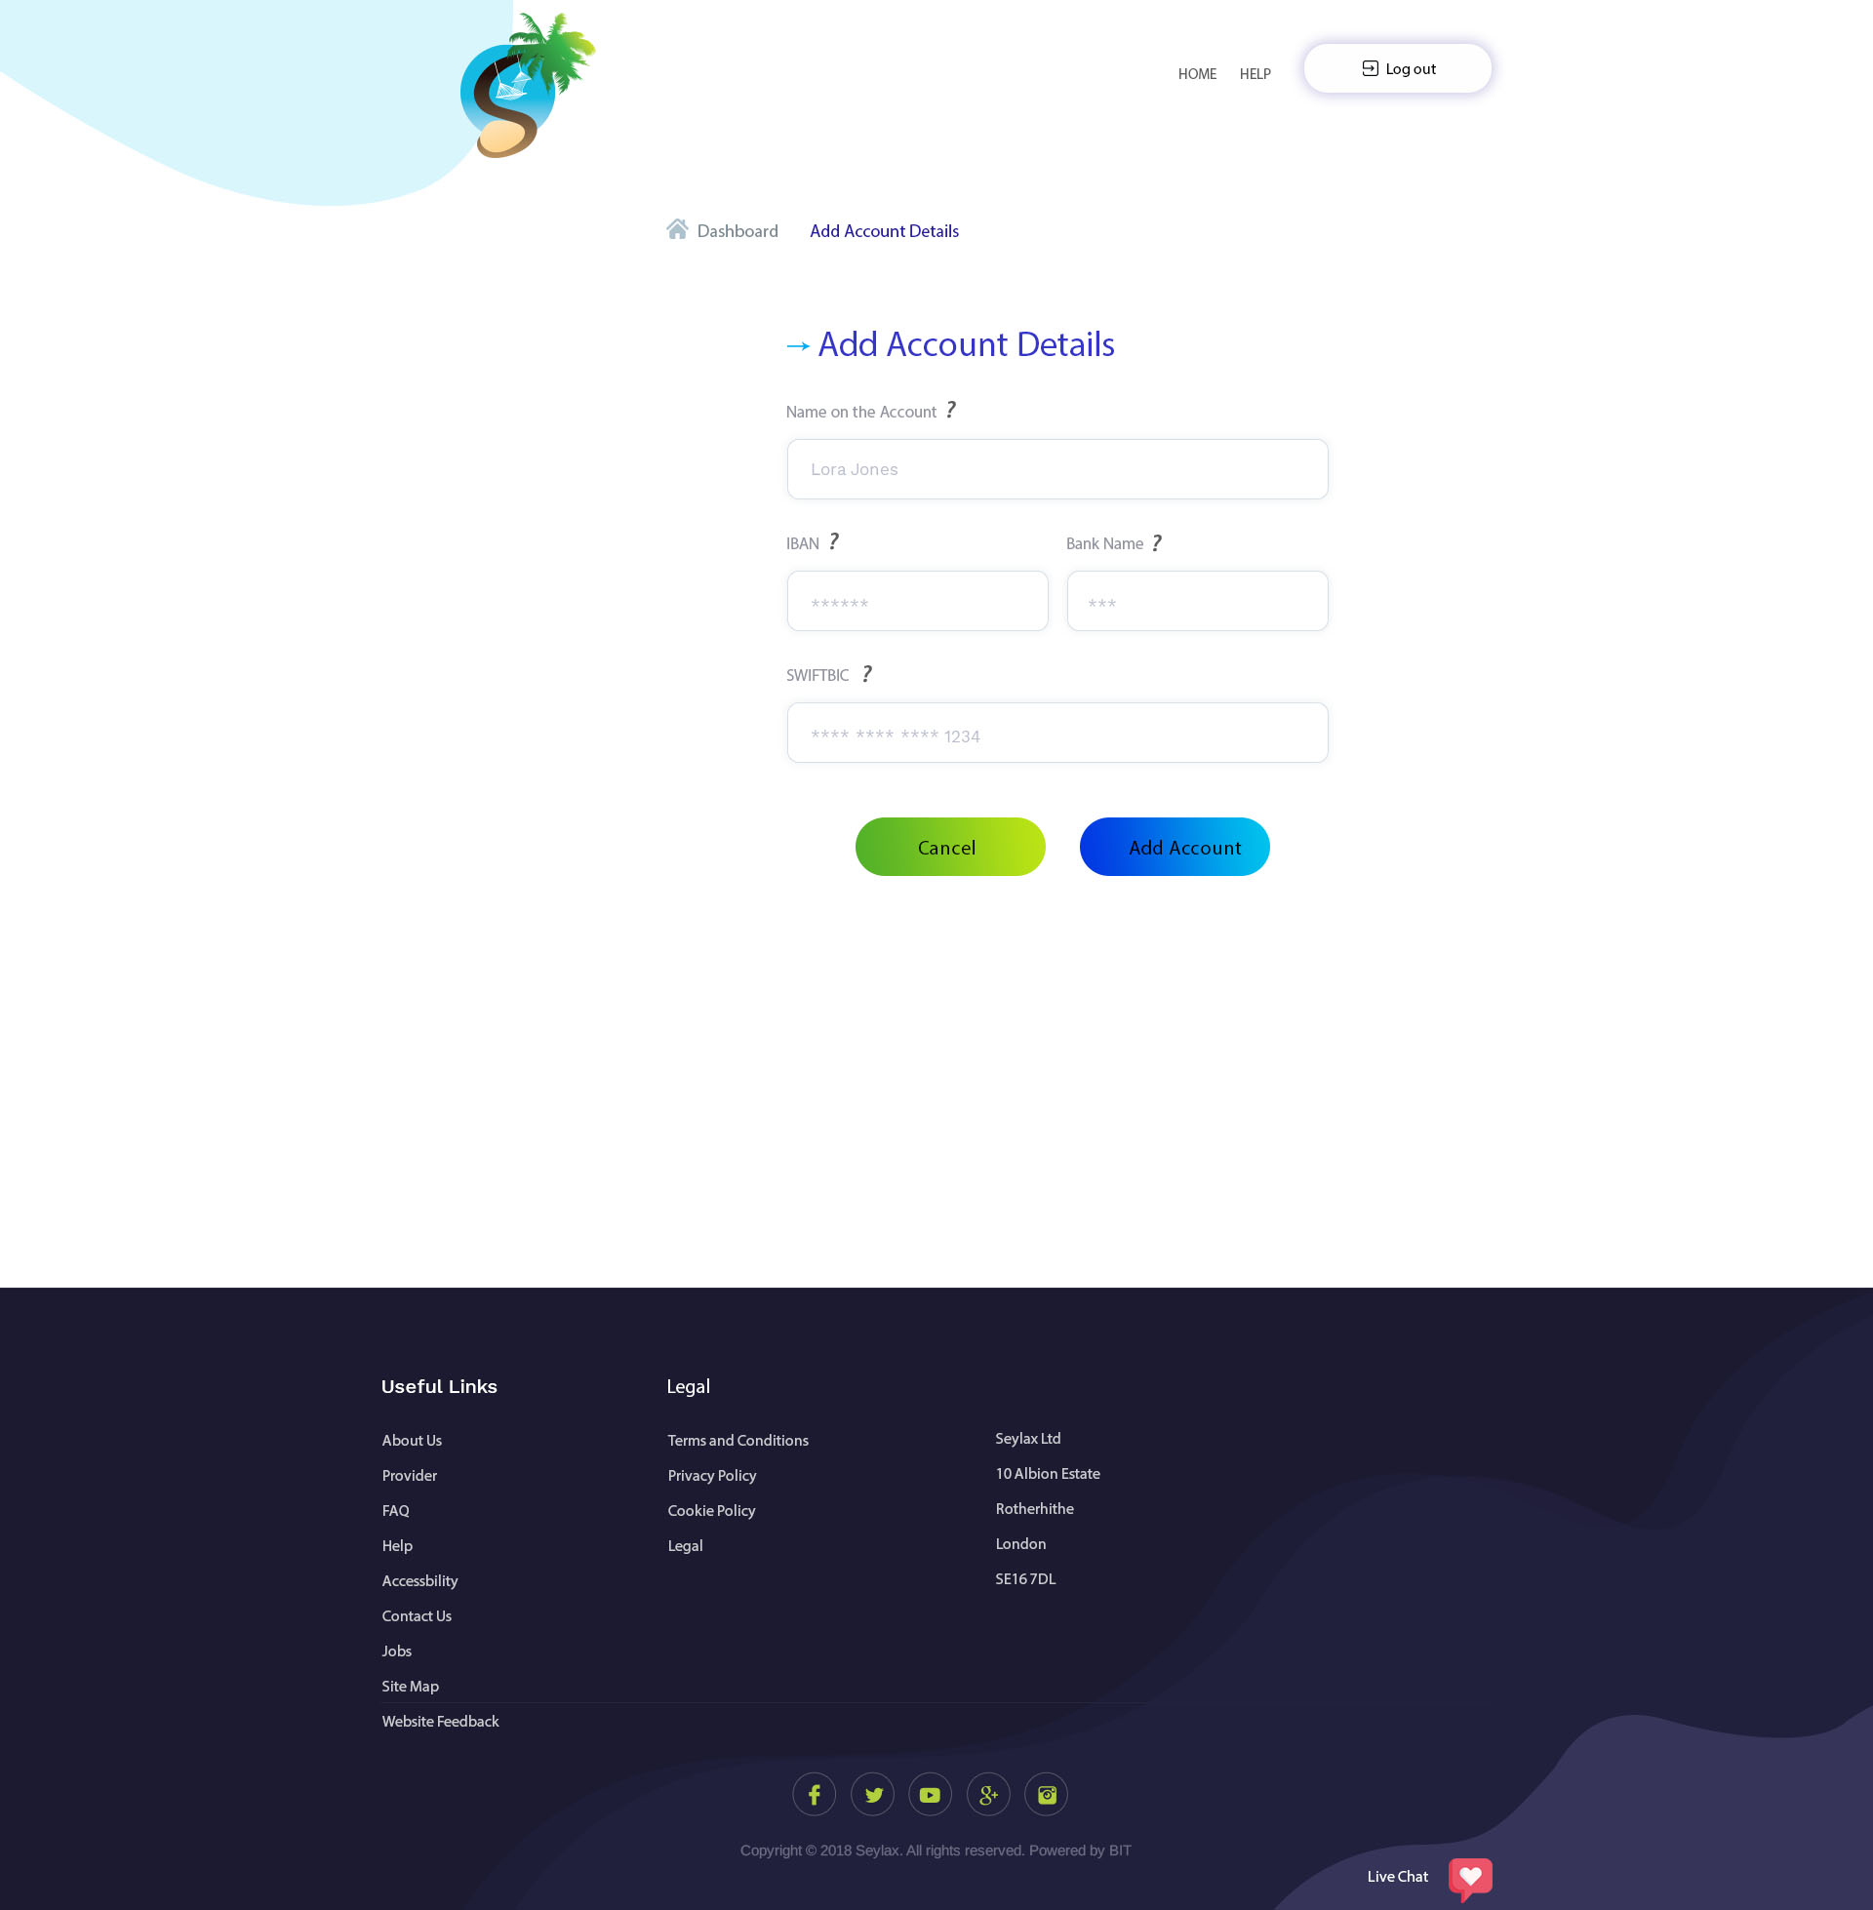

Here they will be able to add in their bank details.

? next to the field for a pop up window when hovered over explaining the function. OK

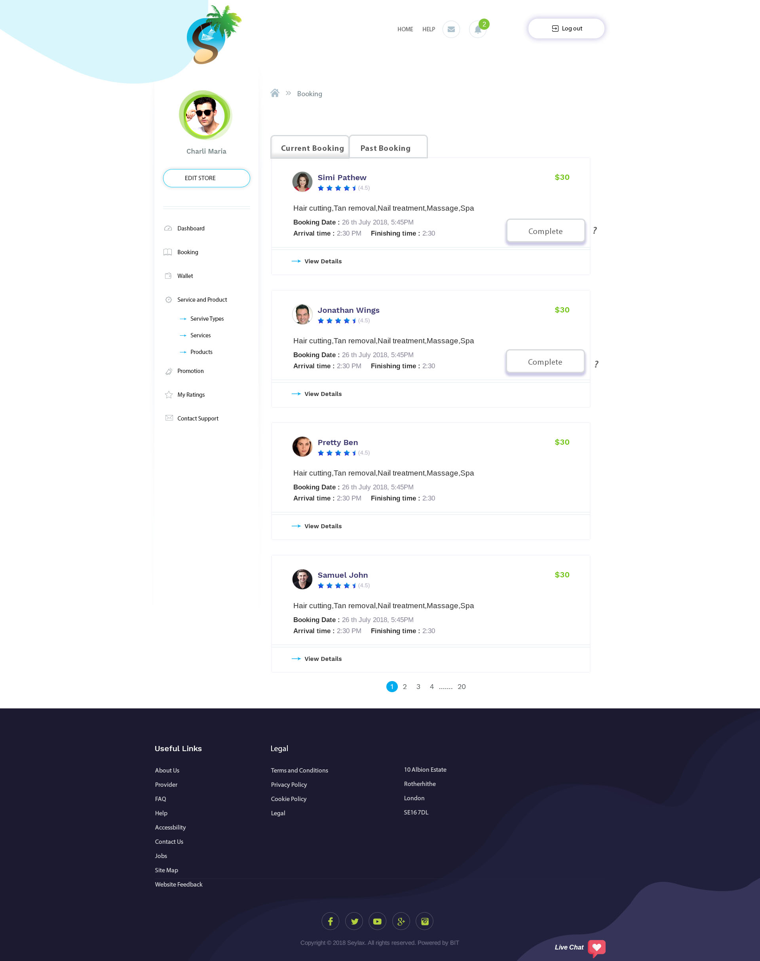

This is current booking page.

When a user is finished with their booking, a ‘Complete’ button will appear asking the provider to click on so that they can finalise their session e.g. it is at 2:30pm and Simi’s appointment is finished, the app will pop up with ‘Complete’ that the provider will have to click on.   
When the provider clicks on ‘Complete’, this booking will move into ‘Past Booking’, and the money will be released from Escrow and into the provider’s wallet minus our commission. An email of the transaction would be sent to both.

On here they will be able to see basic information about the booking such as, service/product they’ve ordered, booking date with time, cash amount, their name, pictures and rating. They can click on ‘View details’ to see more about this order. I will create view details.

Create a view details page.

Add message button here to contact users.

Add cancel button

The bookings would be automatically accepted unless the providers cancel. Can you please add a cancellation button in the ‘view details’ section? In the ‘view details’ section, they will be able to see everything that the user have ordered/purchased

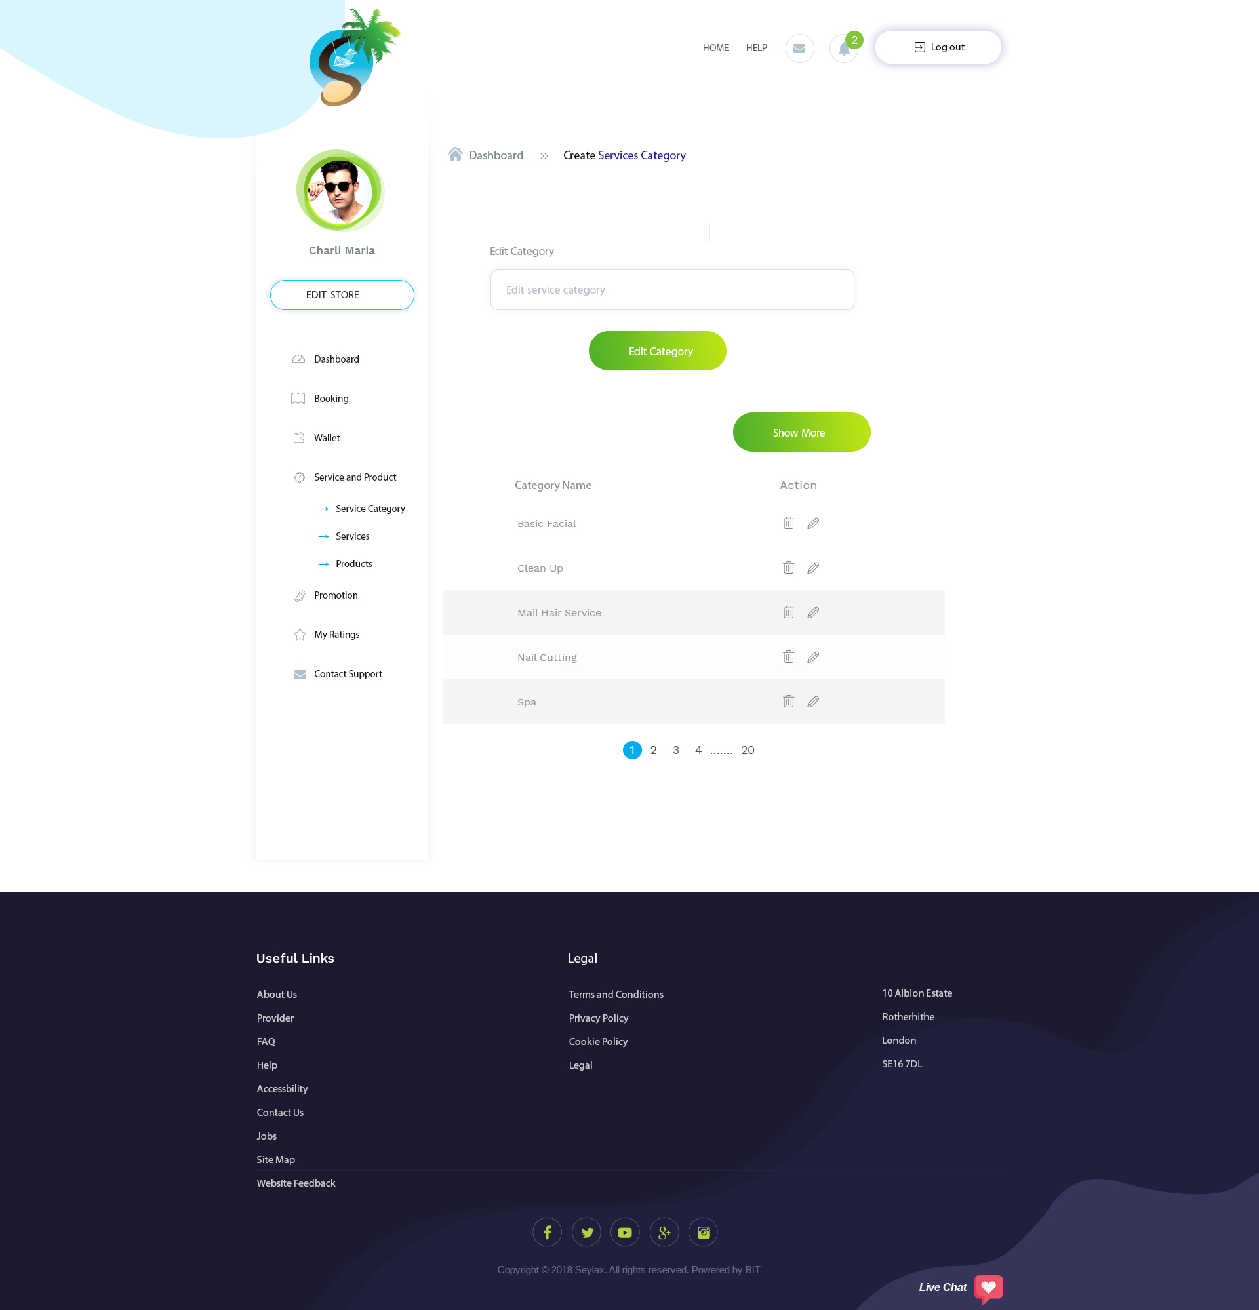

This is ‘Service Category’ from the left side menu. On this page they will create the main Service Category (below page 7 is where they would create the sub Category – Add Service). Main Category is like the title for the category as seen below (this was taken from the store from user’s profile).

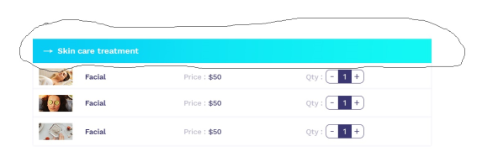

Need to add a show more button

Add ?

You CAN SHOW EASILY HERE WITH OUT BUTTON. IF HERE Data will be more than 10. then need to add show more Button. other wise No need

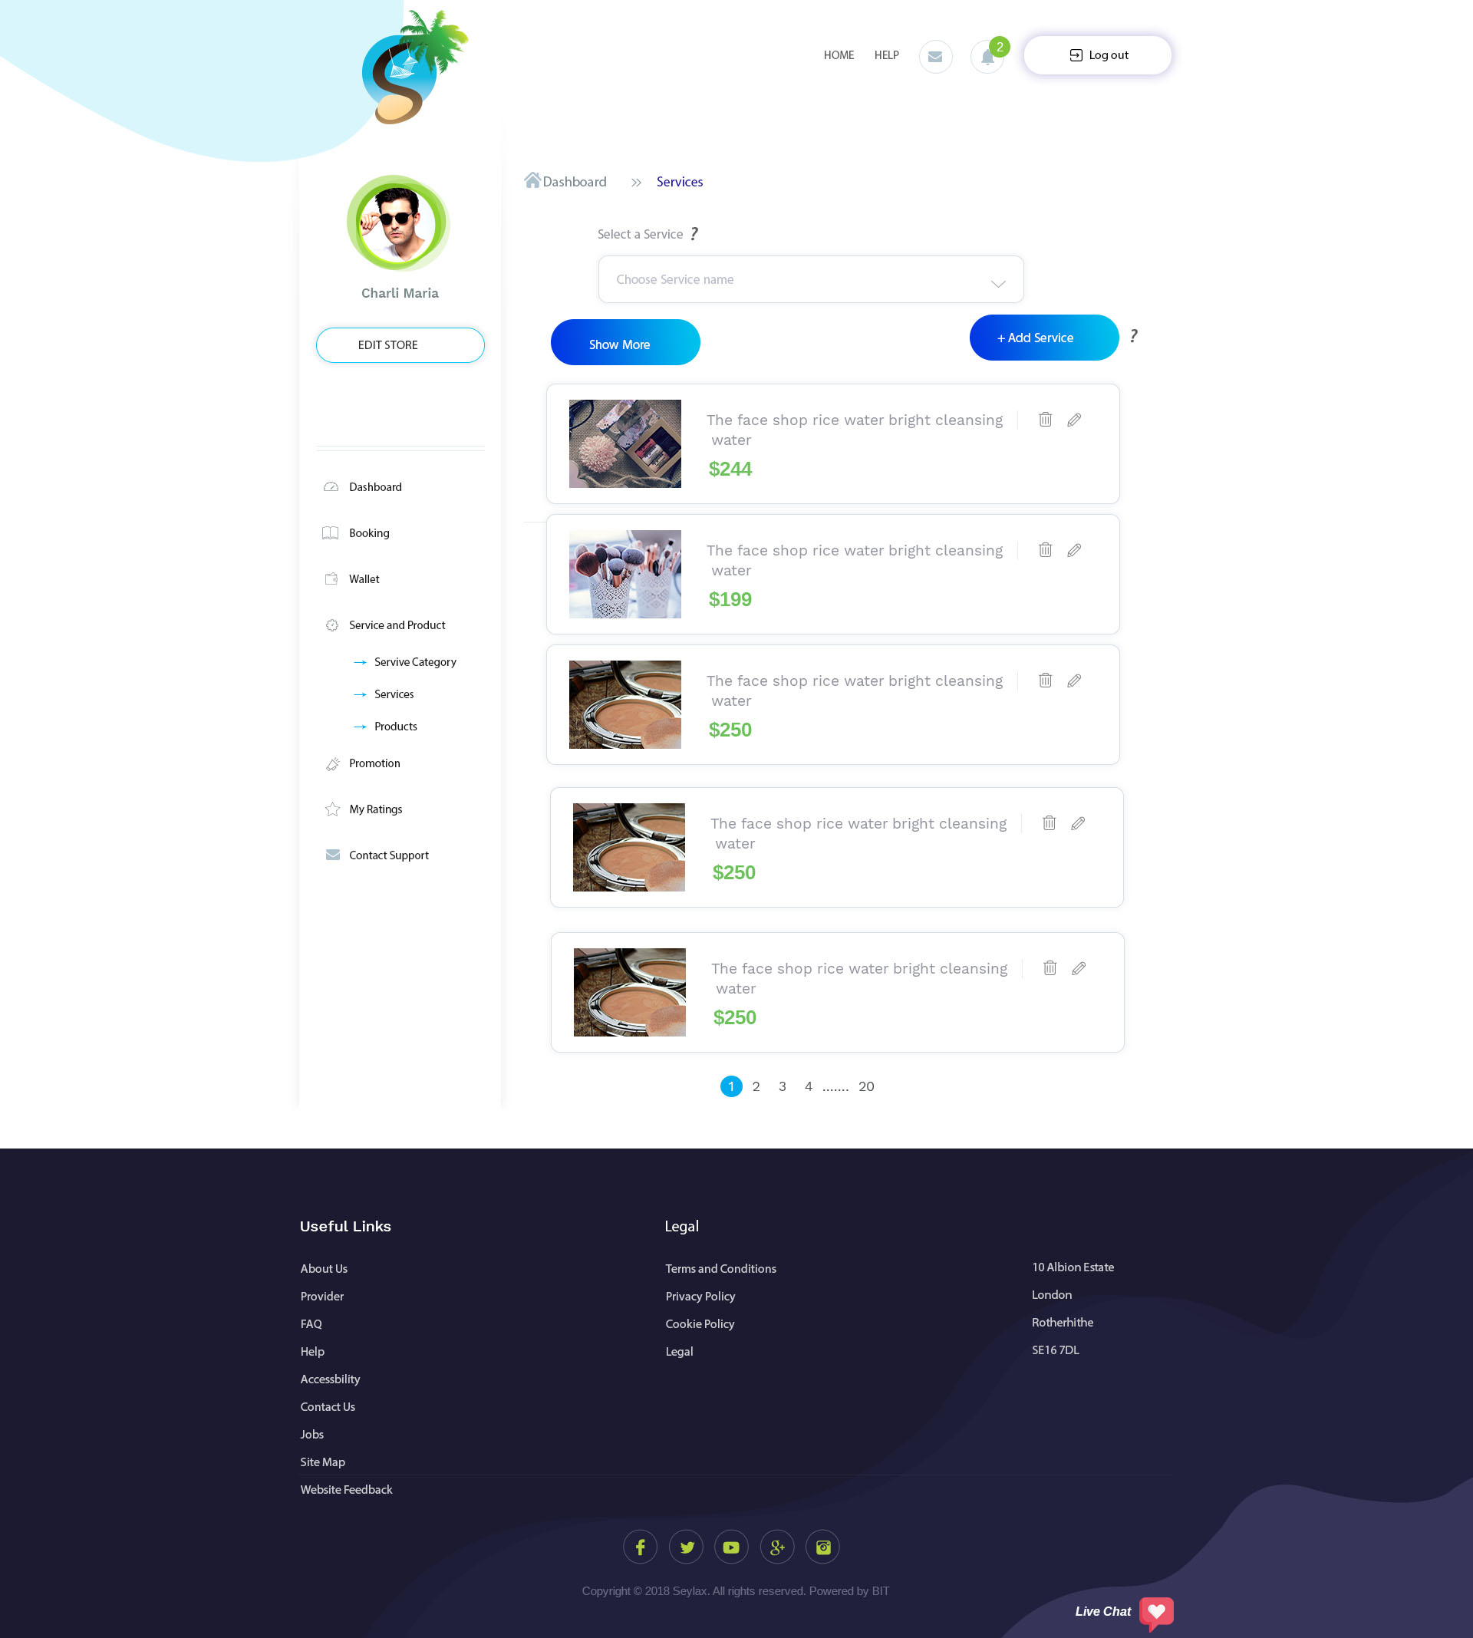

When they click on Service from the left panel, it will bring them to this page.

On this page, they will be able to manage all their services. They can add, edit or delete any lines.

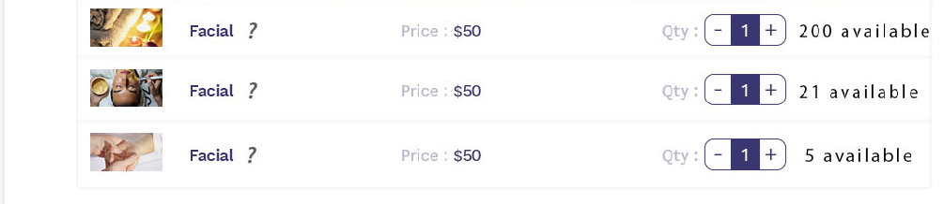

When they click on show more, they will be able to see 10, 20, 50 list on this page.

Availability tab would function like this, when it is un-ticked, it means that the service is available all day during the opening hours/days. When they tick it, they can choose days and time that the service would be available.

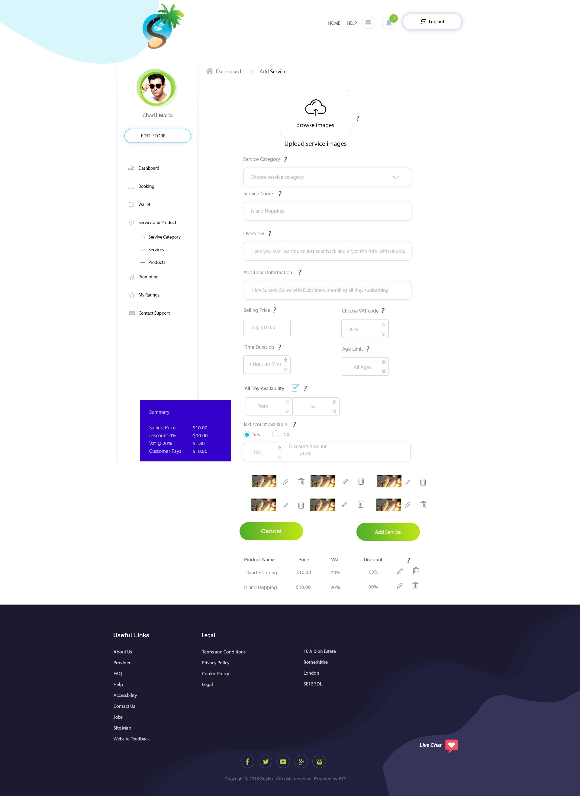

Please add ‘?’ next to the field for a pop up window when hovered over explaining the function.

When they enter a discount amount, on the right will show the amount discounted, e.g. if they enter 10% and the cost is $10, $1 would be shown as it is the discount value.

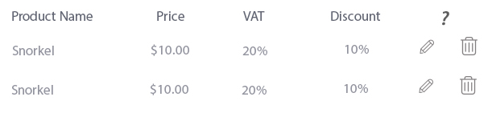This is there for when they are adding multiples of services at one time, it is enabling them to do it faster and more efficiently. We need to replace Date, From Time and To Time with Service Cat, Service Name, Price and discount.   
The pencil is to allow them to edit and the bin is to delete (ask them to confirm before deleting).  
  
We need to allow them to upload up to 6 pictures of their service.

Please add VAT 0% and 15% (similar to page 11). They’ll be able to choose. Admin should be able to change this percentage when the country changes it.

**How each field will work:**Service Category - will allow them to choose what category this service falls under (page 6).

Service Name – They can enter the name of the service here.

Overview – This is where they can describe the service.

Additional information – They can add key points here.

Selling Price – They can add their selling price.

Choose Vat Code – They will be able to choose from 0% to 15%.

Time duration – This is how long a service will last.

Age limits – They can choose from: 7+, 15+, 18+, 25+ or custom (they can enter an age here).

All day Availability – When they tick this box, it means that this service is available all day and the box field would be disable (unable to use the box field). When they do not tick the box, it will let them enter the amount of time it takes to complete the session.

Discount – If they click on ‘Yes’, they will be allowed to put how many percentage their taking off their price and if they click on ‘no’, it will not allow them to use this field.

Edit pictures – all the pictures that they have upload will be shown there and they will be able to edit or delete.

On the left would be the maths calculation. This will help them to understand to cost.  
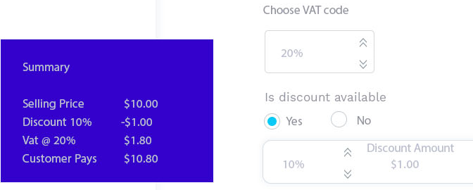

  
When they click on Snorkel, below page will open (in the same window as a pop up) so that they will be able to see the service information page.

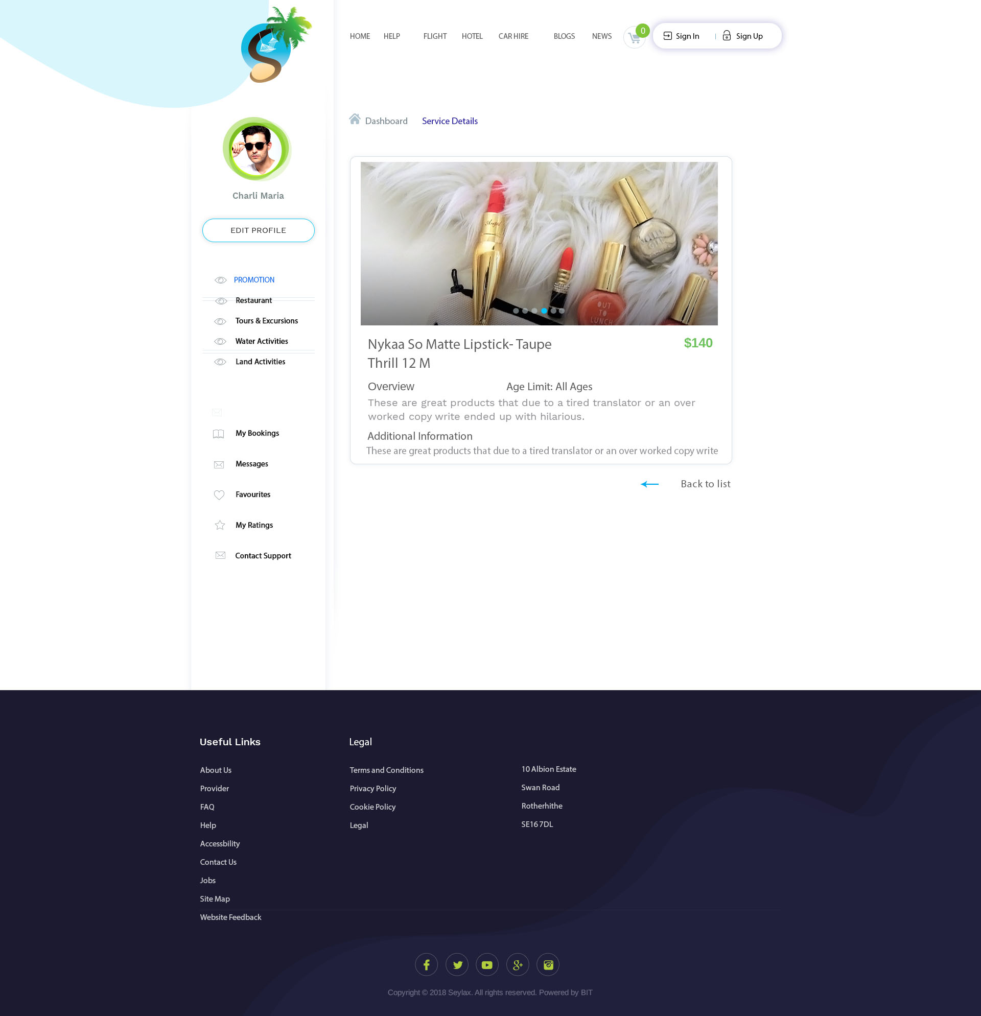

Add and edit pages are the same (same designs and fields) with the only exception of edit page already having the service information (previous service information already saved). Same functions as page 8/9.

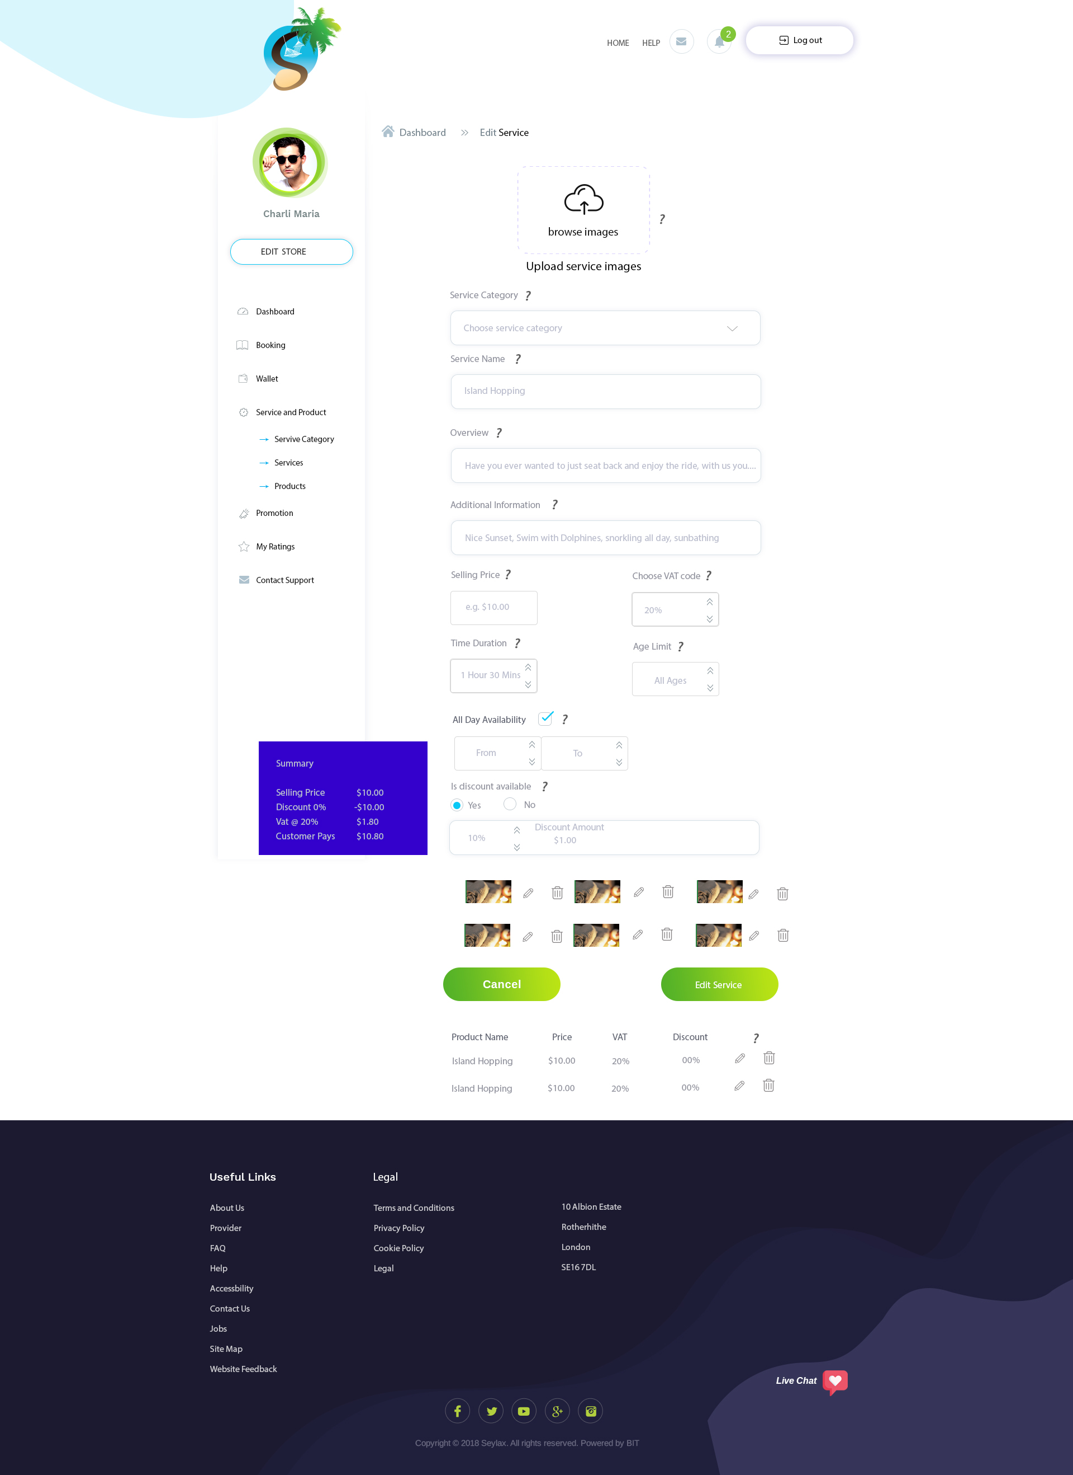

When they click on ‘Product’ from left panel, it will bring them to this page where they can add, edit and delete products.

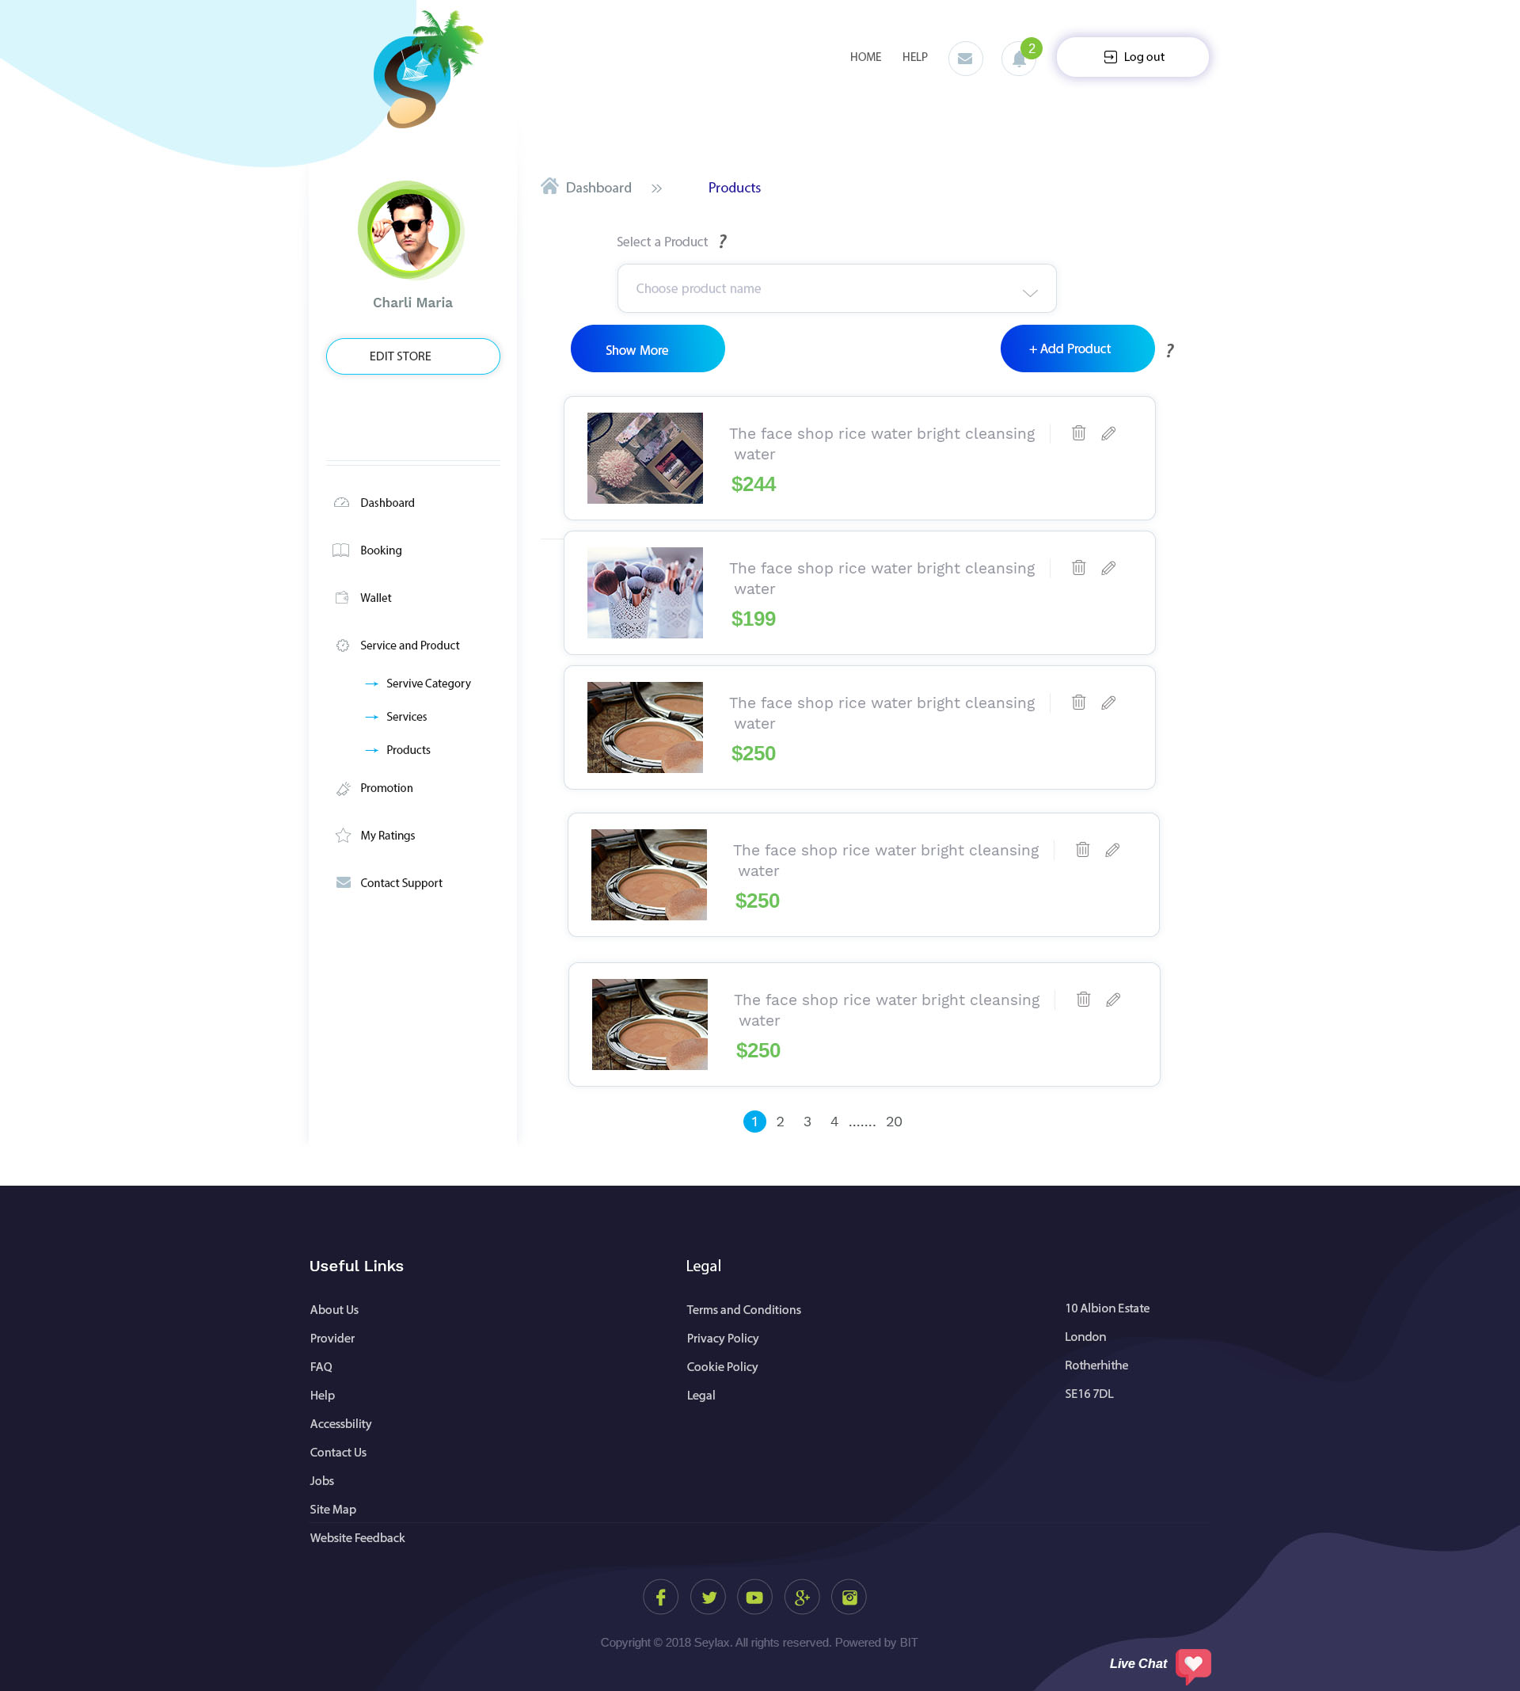

Show more would allow them to see 10, 20 and 50 items on the same page.

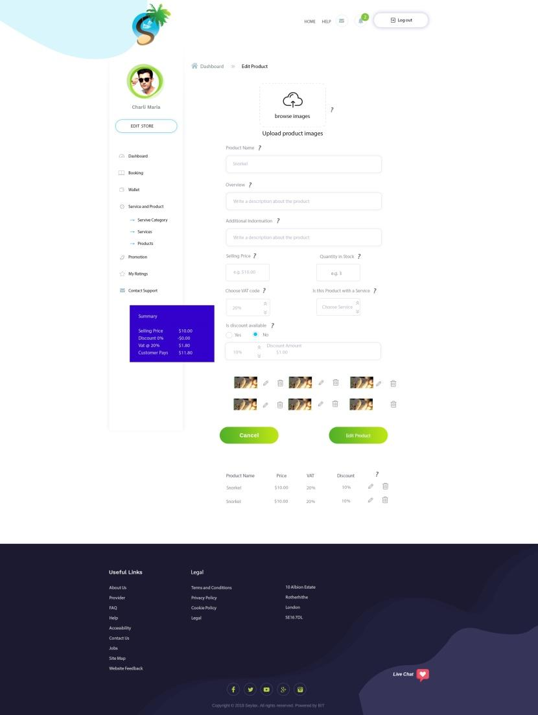

This is very similar to adding service except for 2 new changes:

1. Provider can add how many item they have in stock.
2. Is this Product with a service? This means that some service might have product that goes along with it. When they click on this box, a list of all the service will appear in a drop down menu for them to choose from. When they have chosen the service, this product will appear with the service on their store.

They can also add up to 6 pictures.

Every time someone by a product, the stock amount will decrease (similar to amazon).

After they have created a product, they would be able to view it. IF they click on the product name, it will pop up like page 14.

Change edit product to New Product.

OK

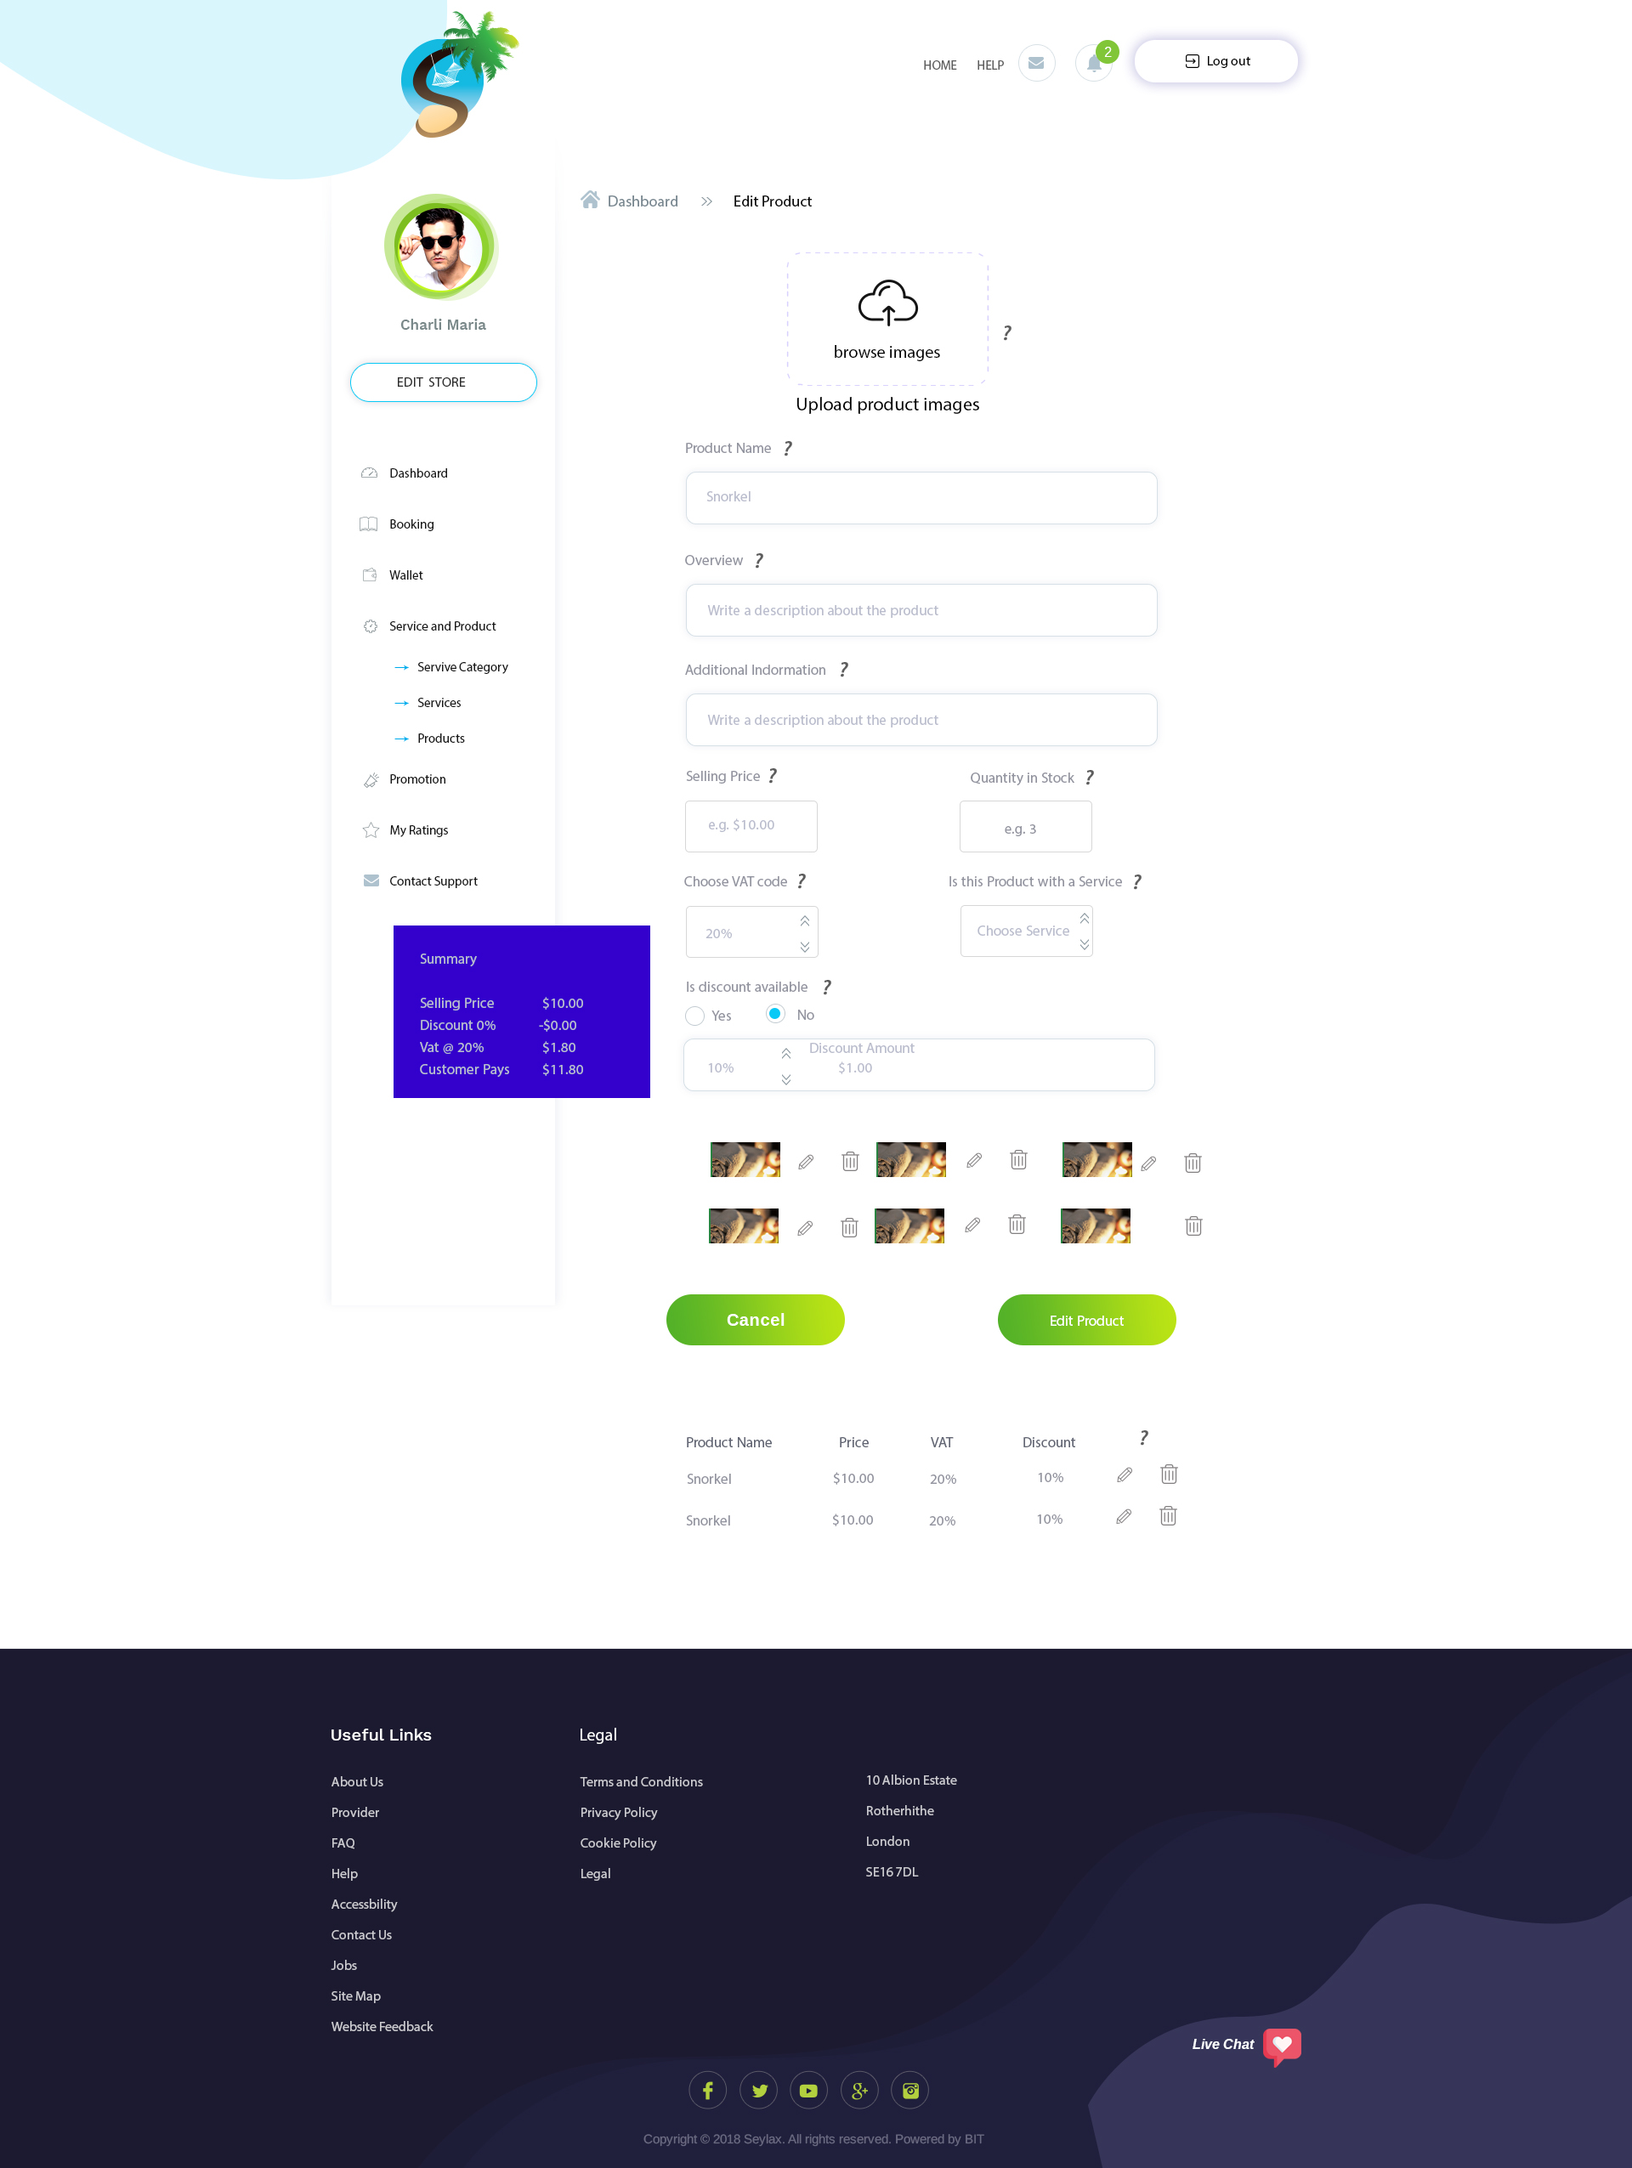

This is edit page, and it works the same as page 12

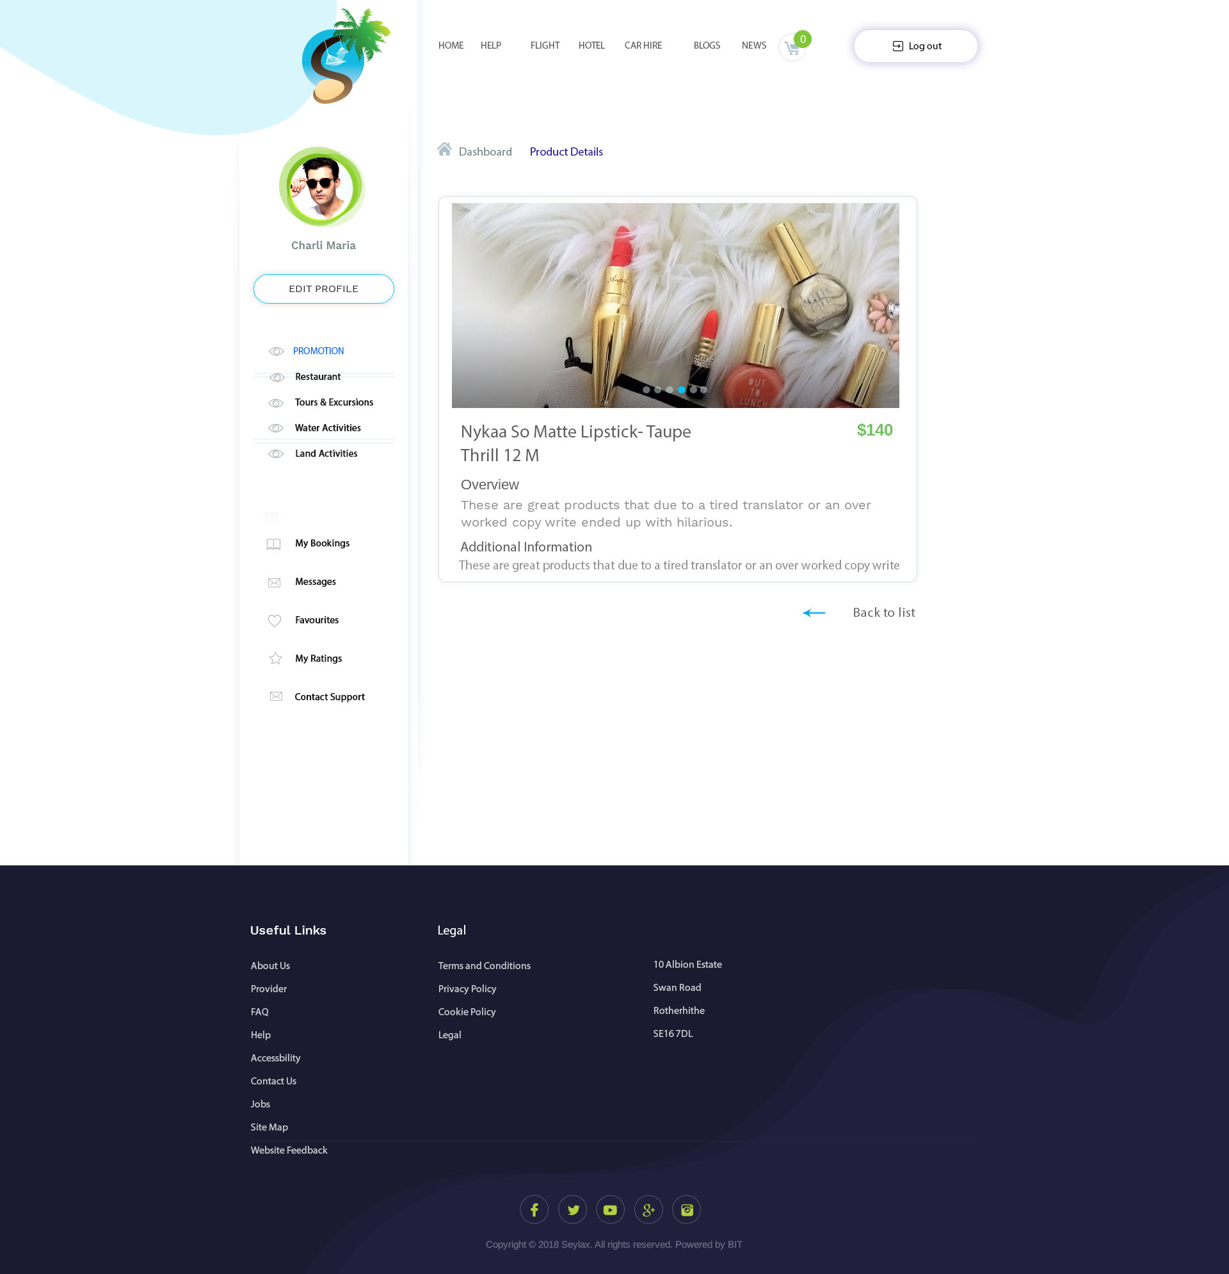

This is how the product page would look like. After they have created a product and click on that product, a pop up page will show this page.

Add stock amount here

Add an archive button, instead of deleting the messages; it will be stored away for a length of time. Add an archive button so that they will be able to view the archive messages (similar to PPH). Question - Would admin be able to set the length?

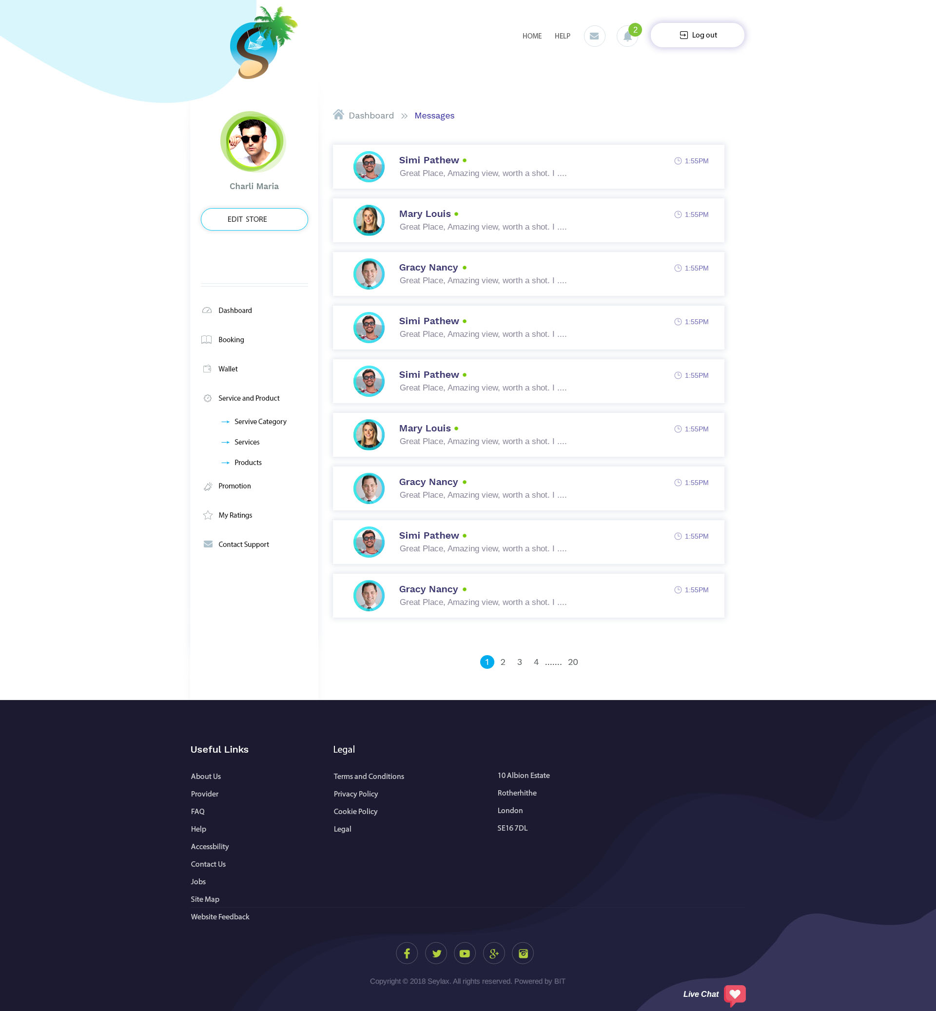

YES. ADMIN CAN SET.  
  
This is where they will see their messages and be able to reply to any other messages.

This is a chat message between users and provider.

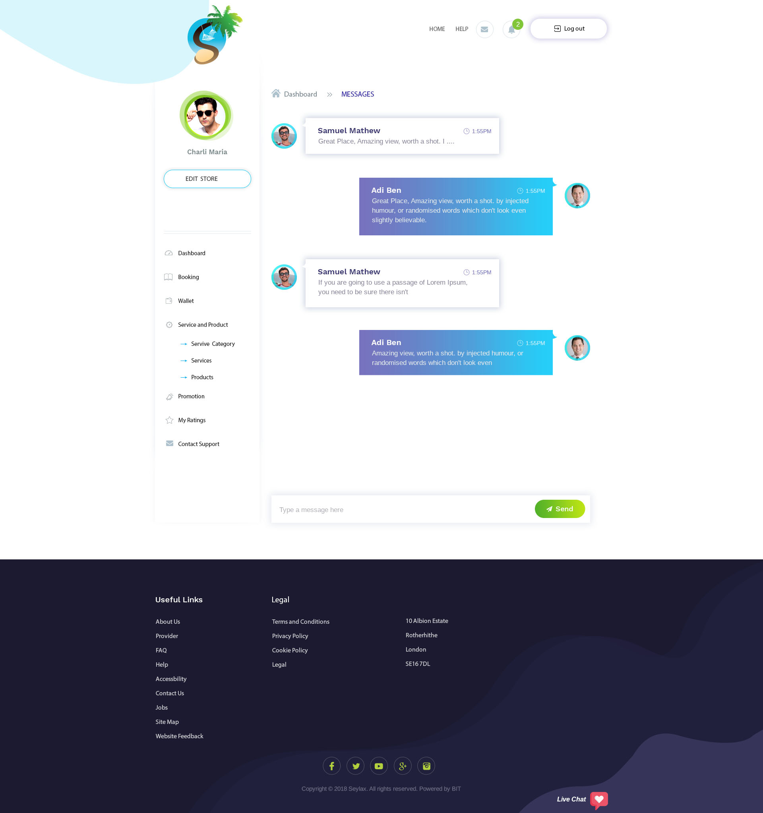

Email notification would be sent if they are not online. If they are online, in browser notification would be sent (similar to PPH).

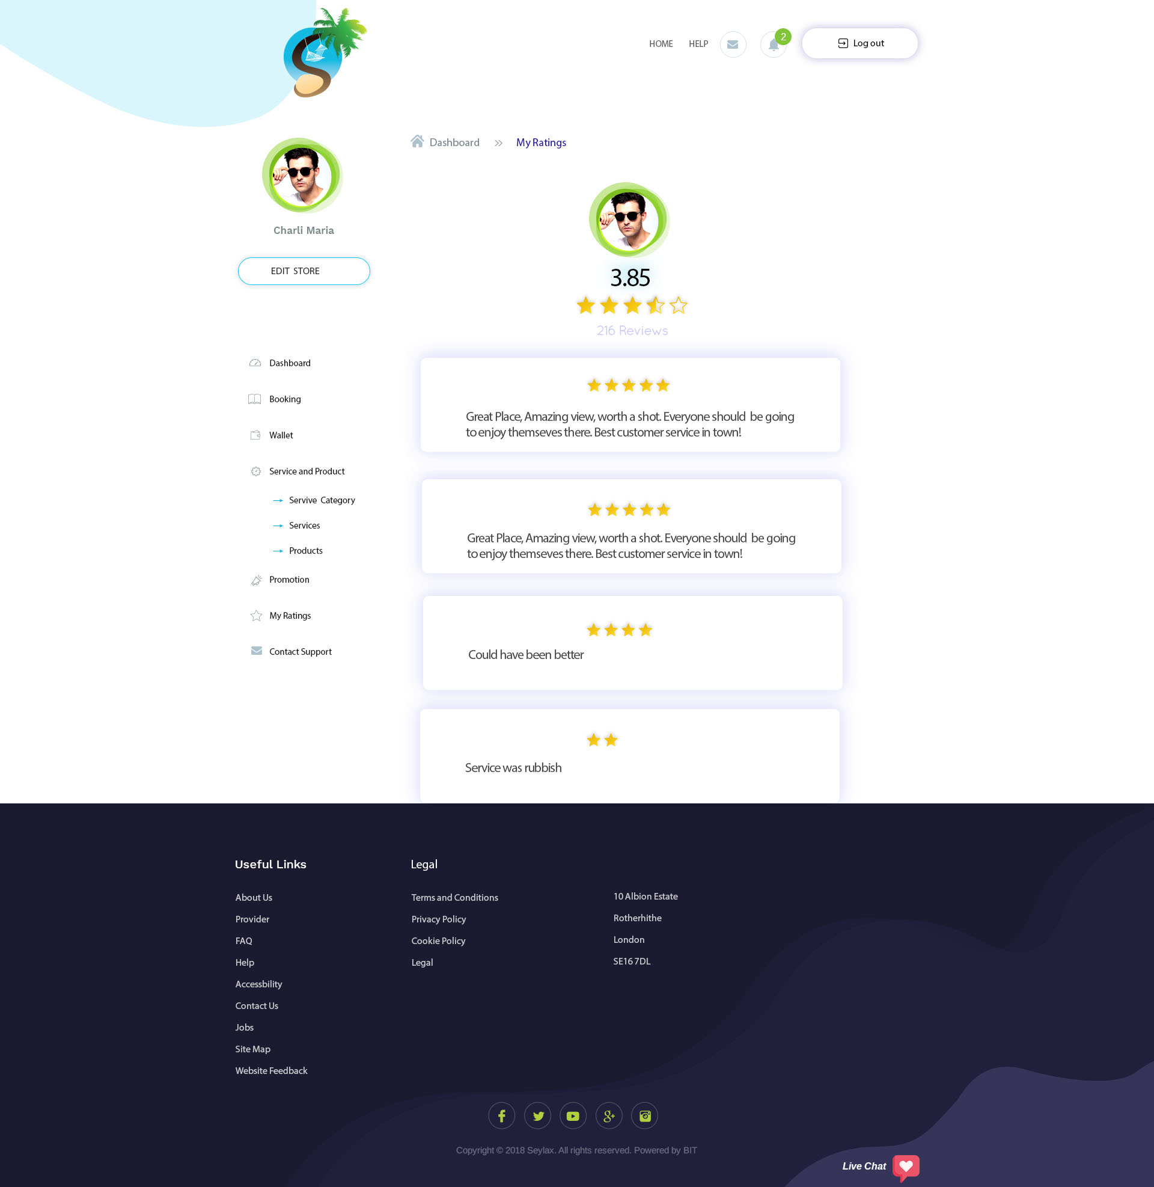

When they click on my rating, this is what it will show.

Create page for where they will rate  
OK

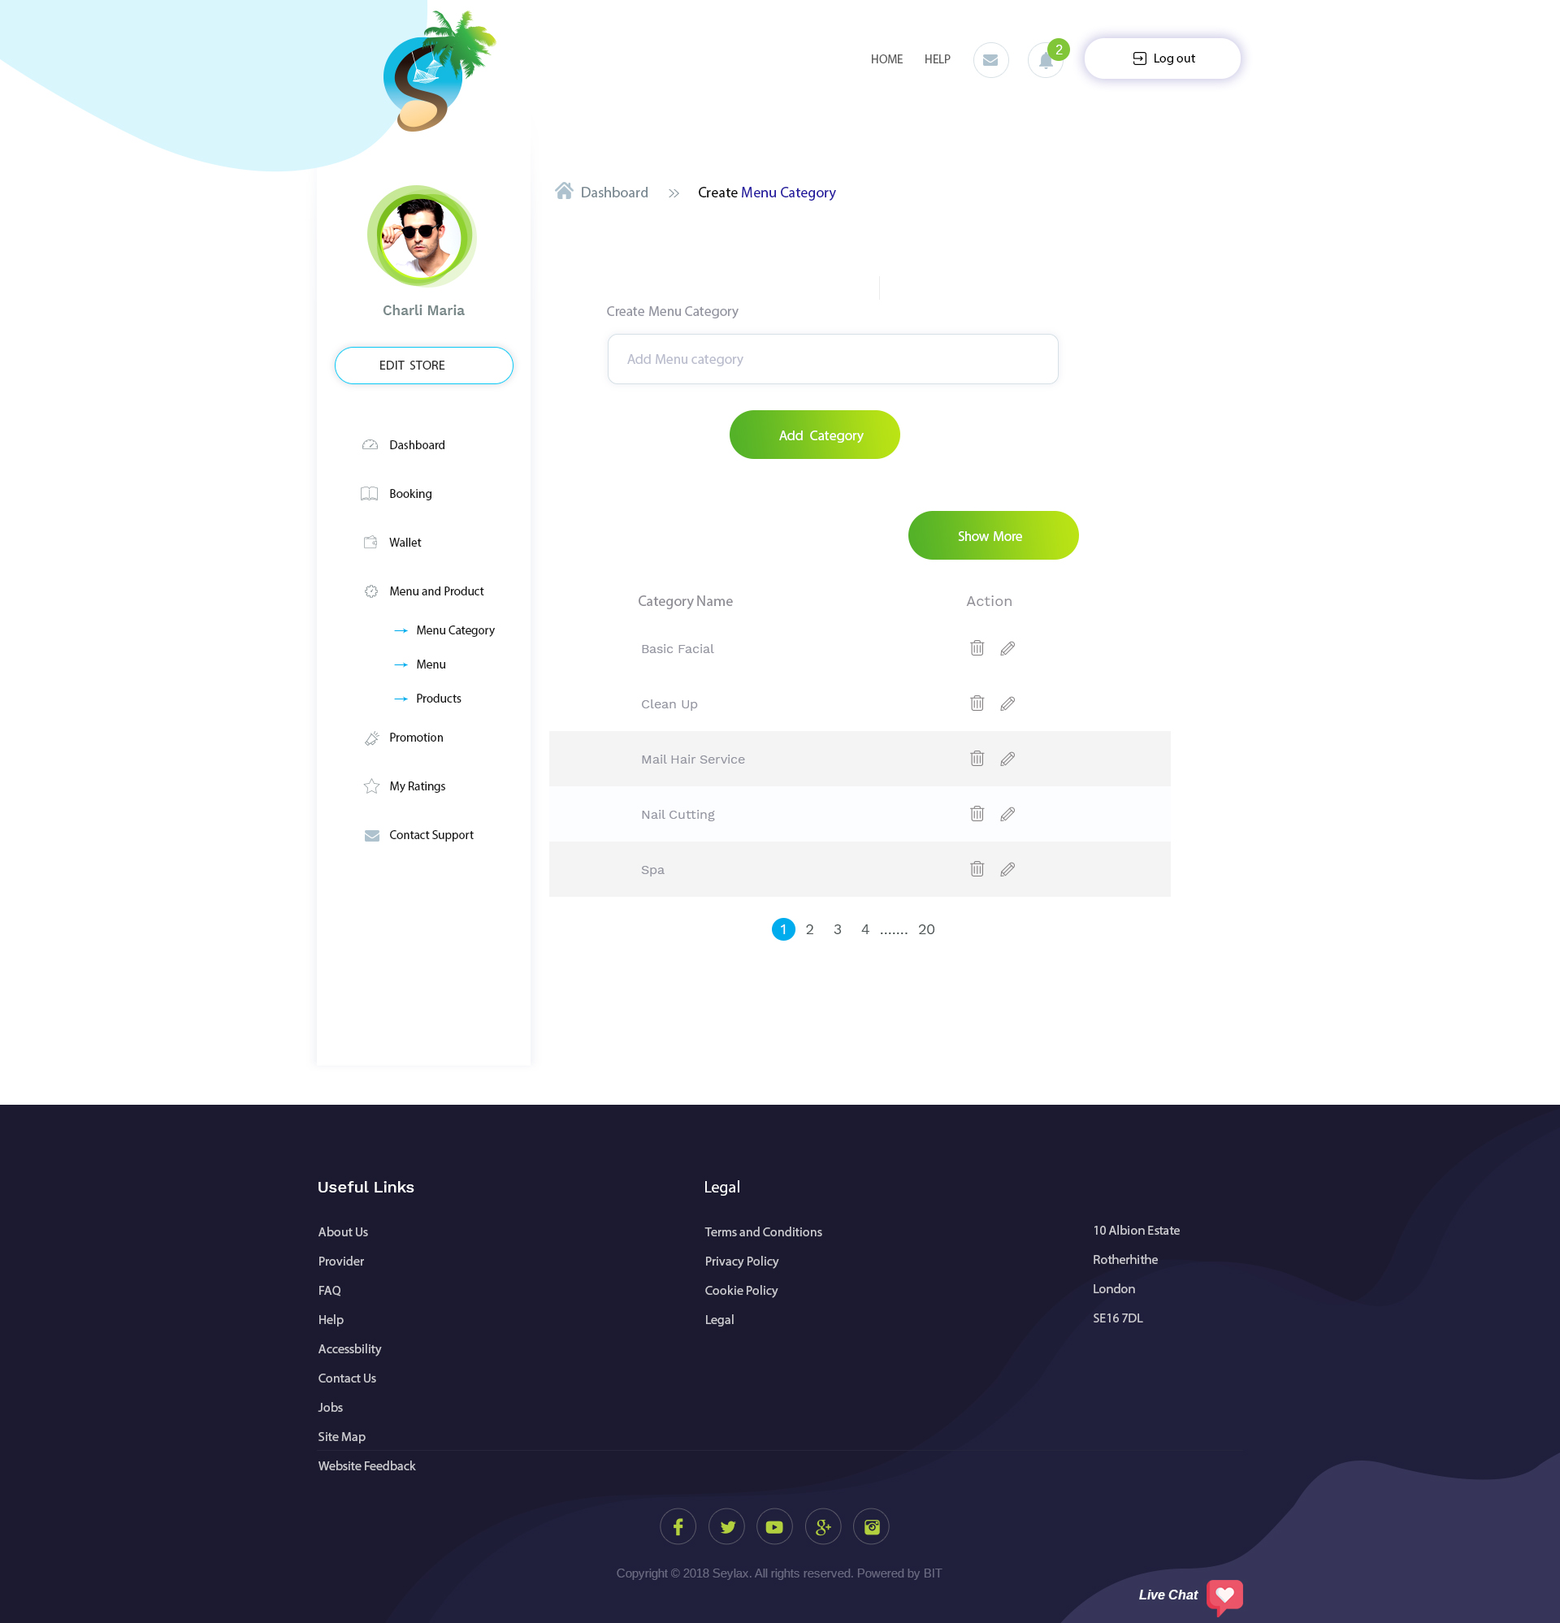

This page is only for restaurant. They will be able to set up menu category from here.

Store create/update would be same as other except for an additional field called Average Spending Per Adult and Average Spending Per Kid.

OK

As you can see, the left menu has different names – instead of service, I have changed it into Menu.  
  
This is the restaurant menu set up page.

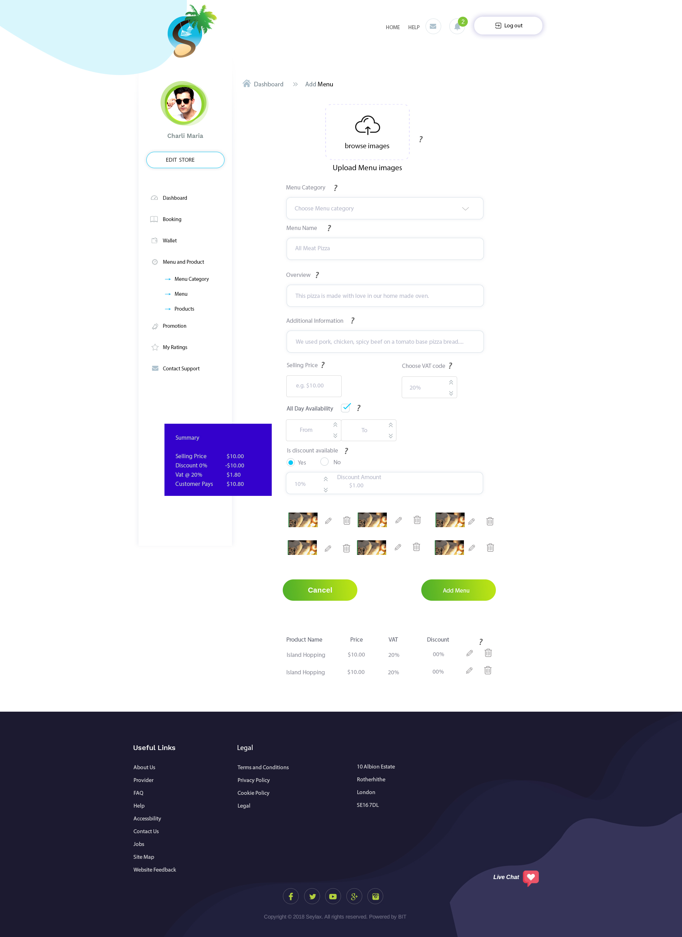

Add and edit pages are the same (same designs and fields) with the only exception of edit page already having the service information (previous service information already saved). Same functions as page 8/9.

Edit user page to how additional info will look

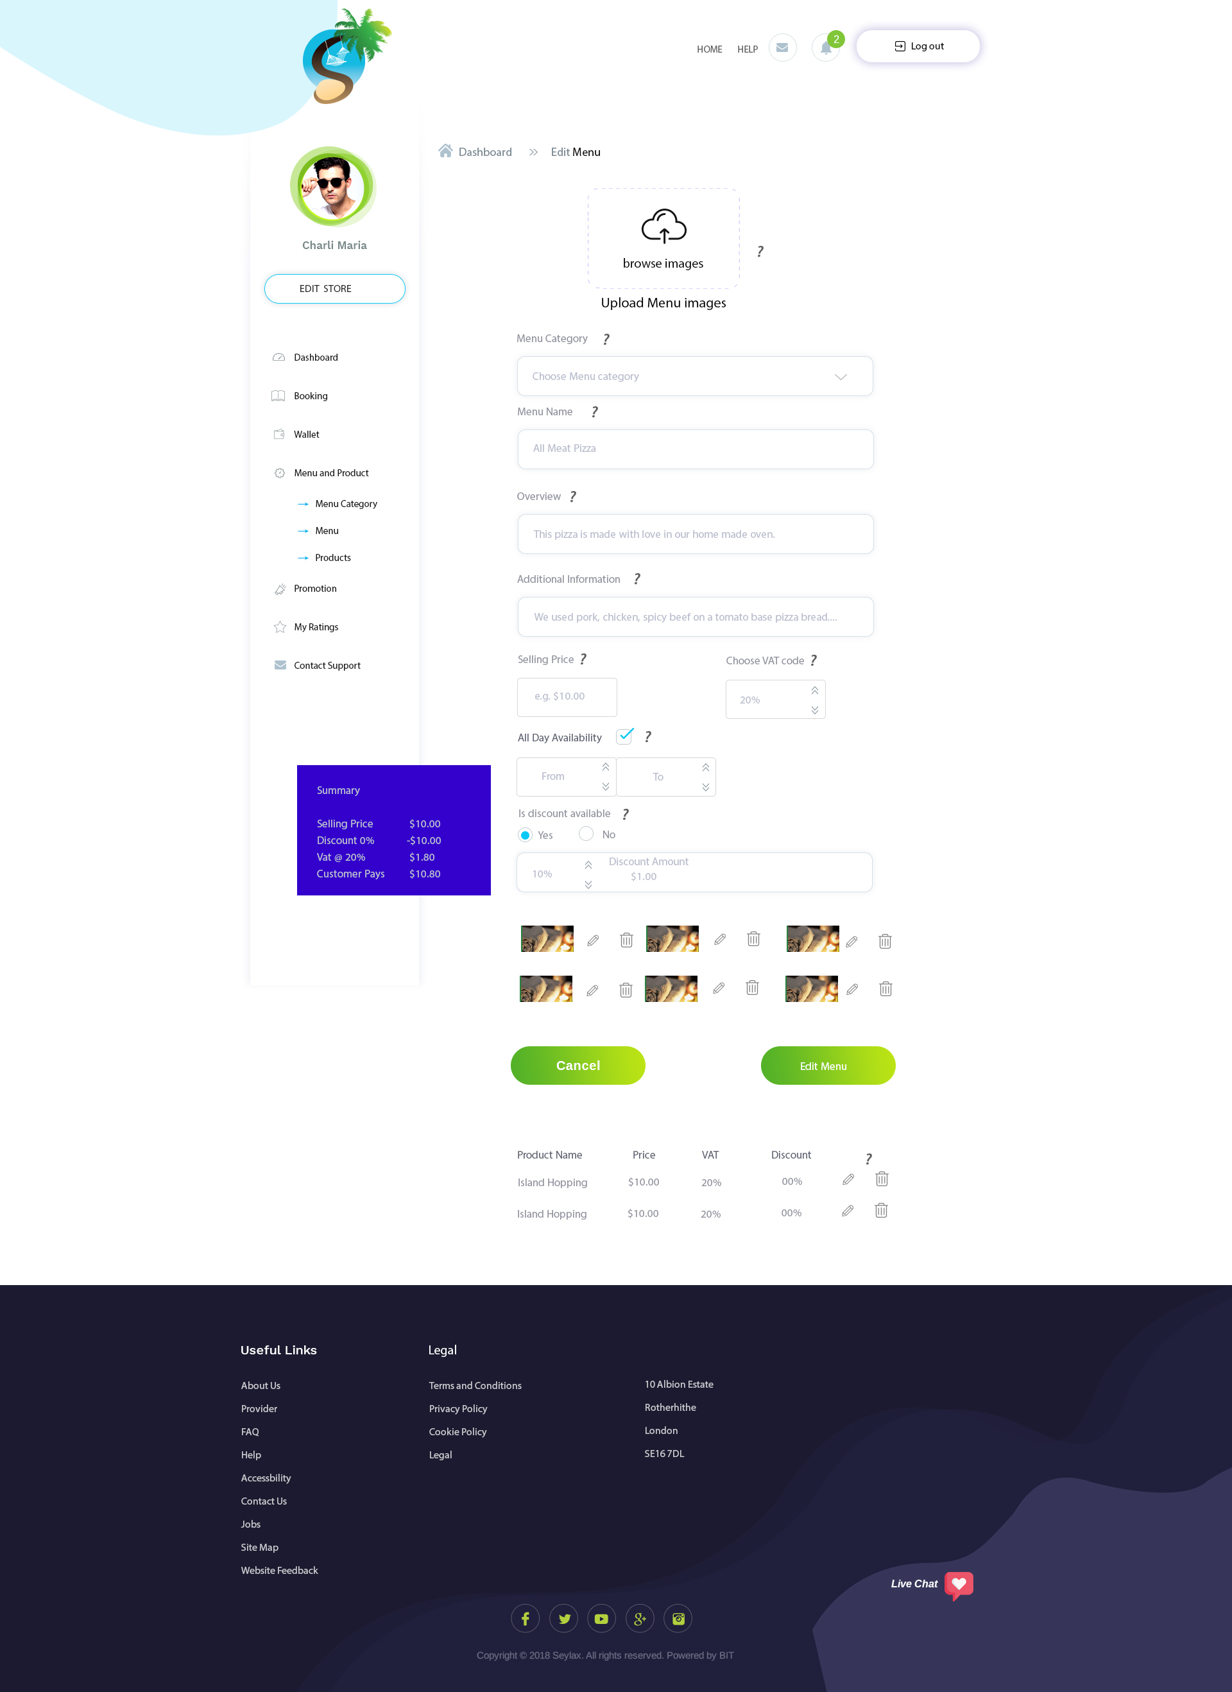

Add and edit pages are the same (same designs and fields) with the only exception of edit page already having the service information (previous service information already saved). Same functions as page 8/9.

At the end of their dinning, an option would pop up on the Provider’s current order asking them to enter the final amount and to also take a picture of the receipt and submit it to us. Only after that the money would be adjusted (if less they get refund and if more then we charge extra) and debited into provider’s wallet minus our commission. They would also be able to add in the table number that the user would be seating at. This would be able to be done from Current booking page.

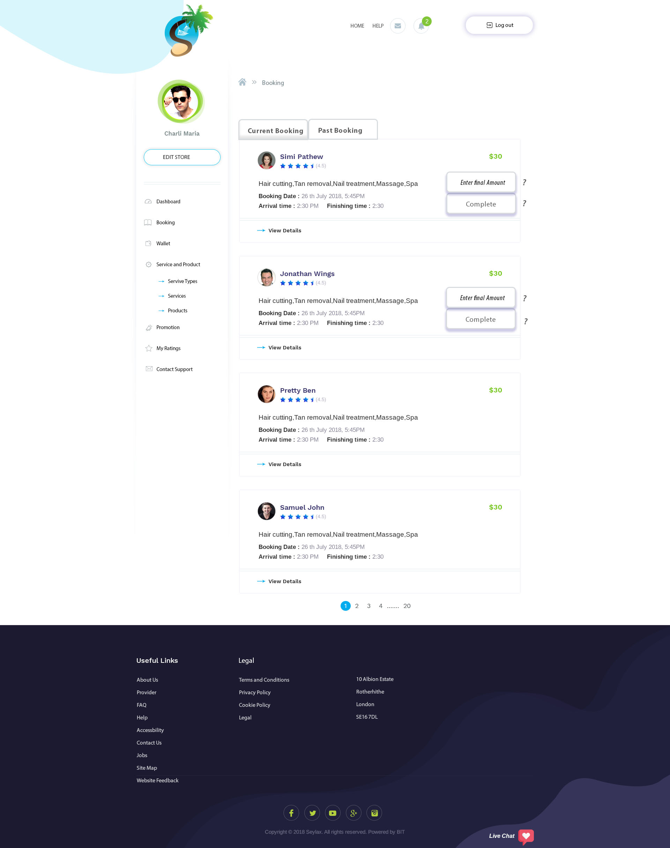

Page of uploading receipt

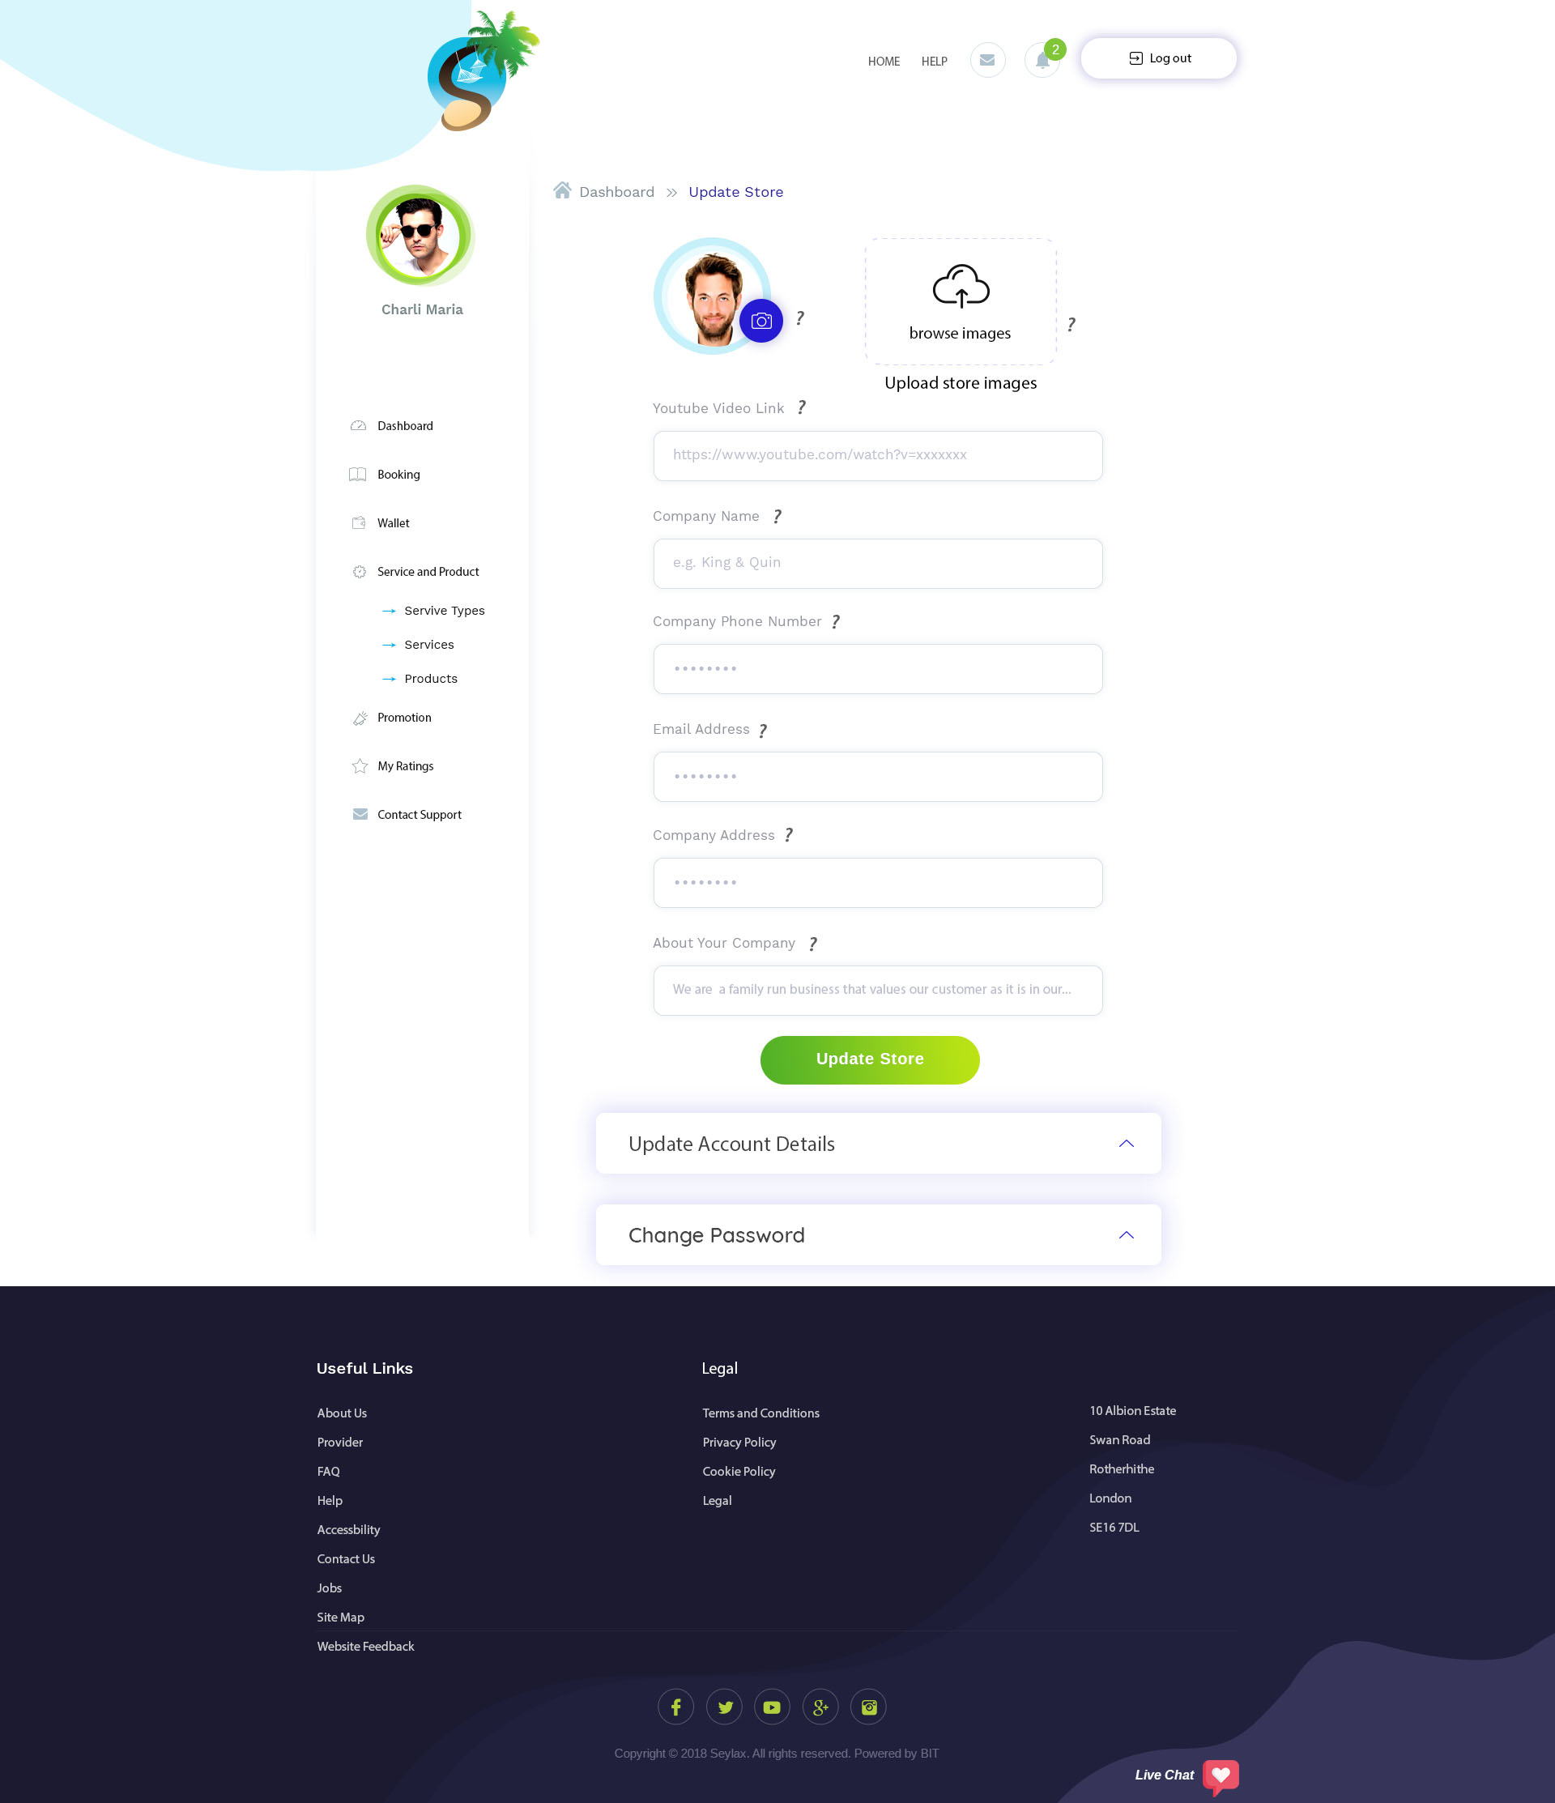

This is update store page. It works the same as page 3.

On this page, they will be able to update/change their account details.

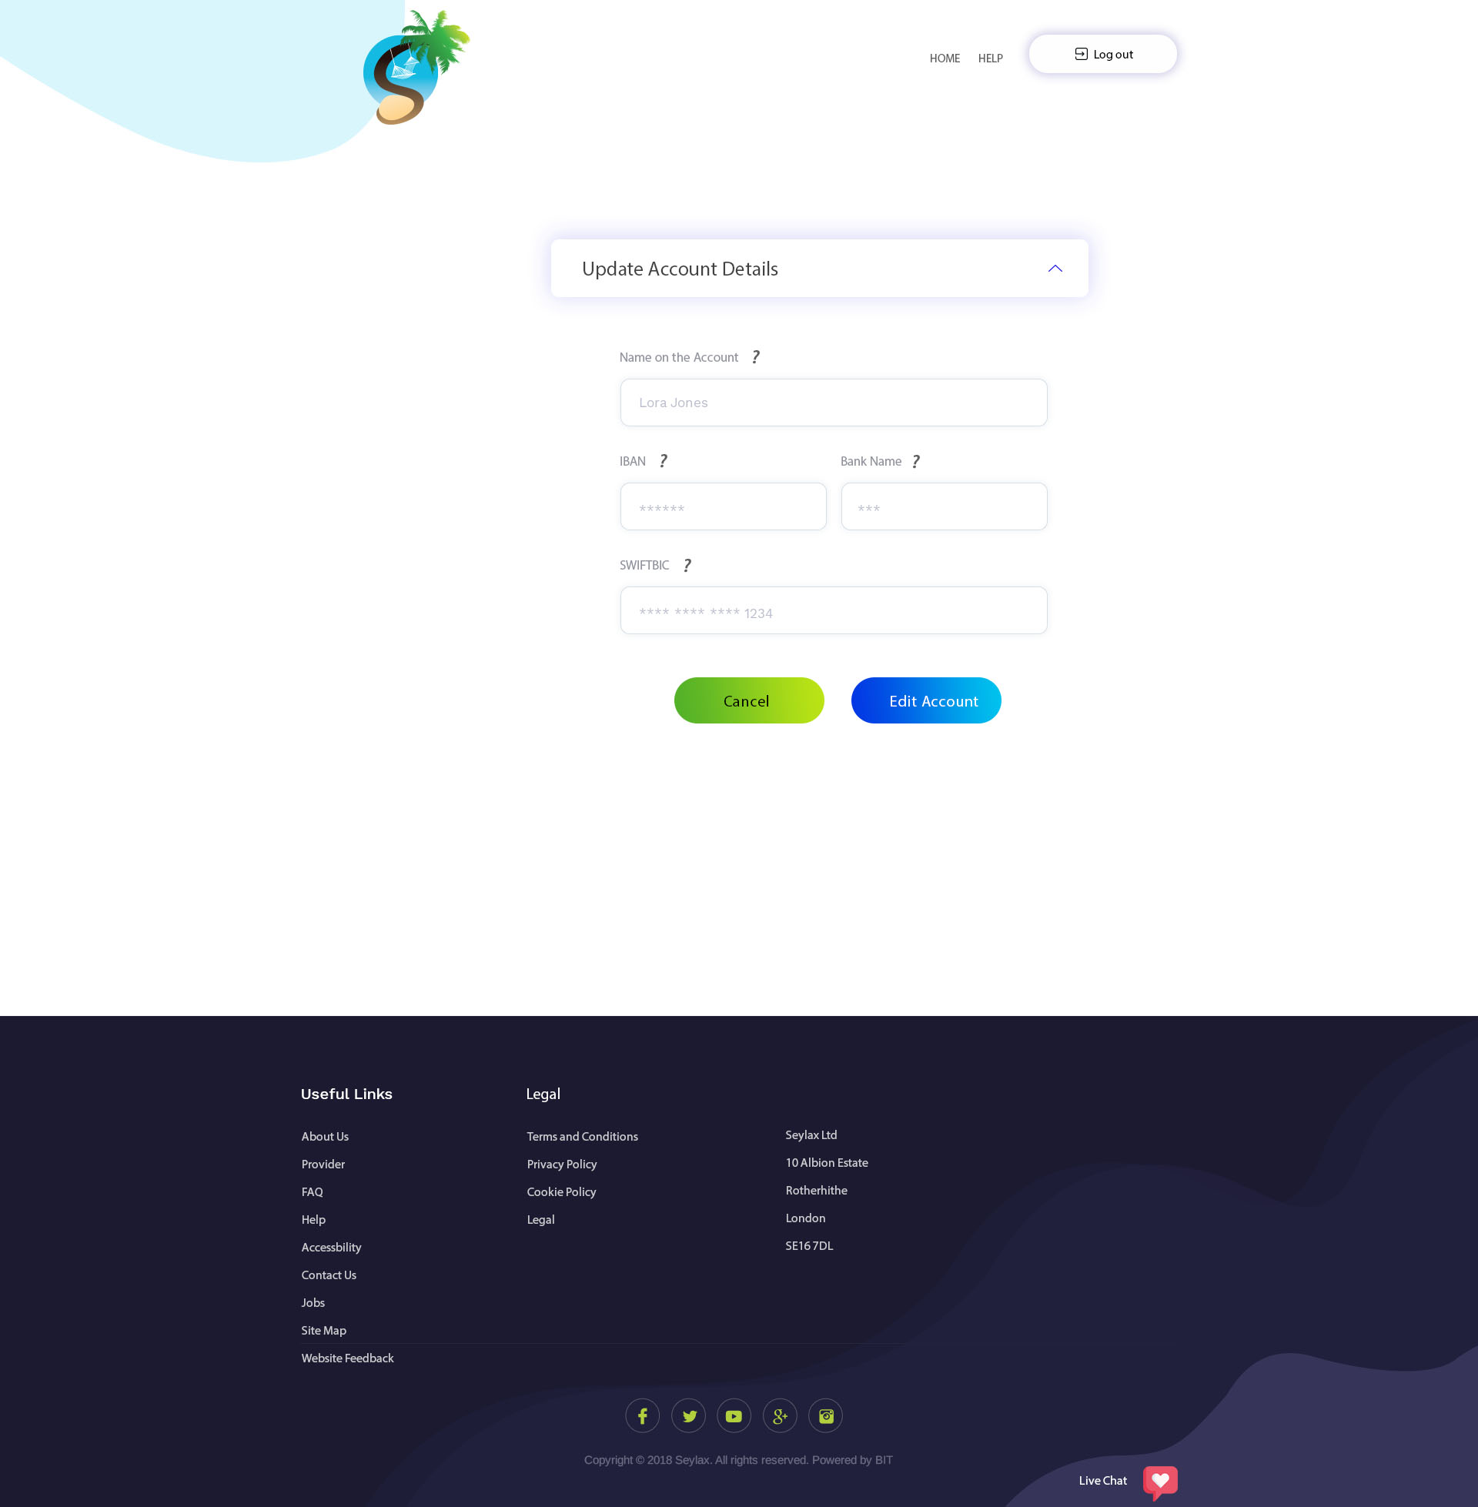

OK

This is past booking where they will be able to see all their old bookings.

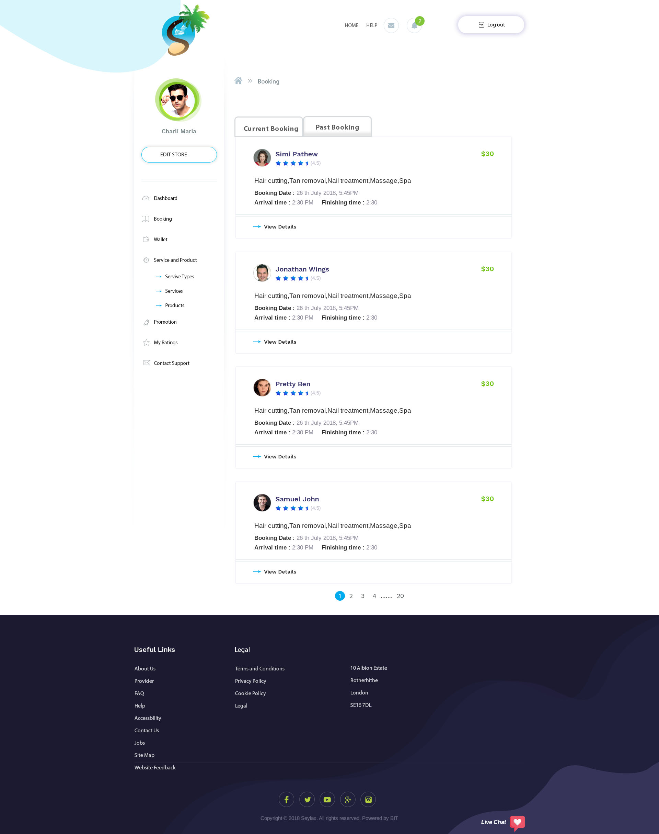

After the provider and user have sign up; this will be the page where they can log in.

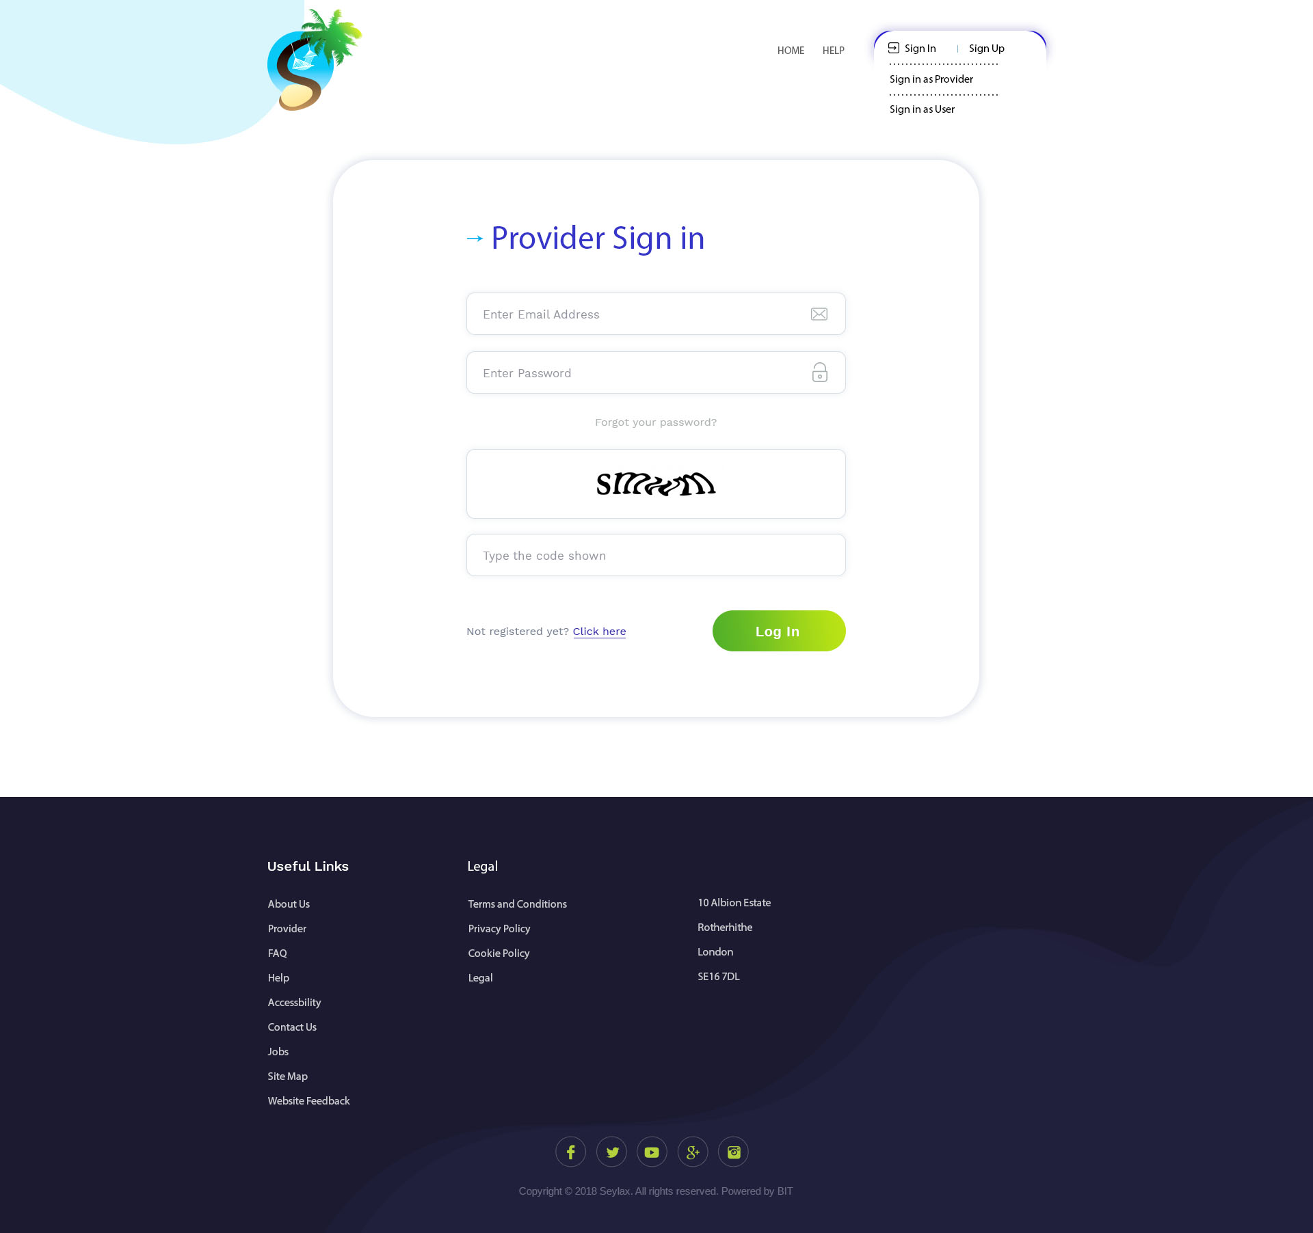

We will use captcha before allowing them to log in.

OK

This is where they can contact Support. When they click on contact support, it will re-direct them here with the chat to support.



WE will use Google analytic to record how many people use the website and how long they spend on the website.

Page Missing

Wallet

Promotion

Rating

Favourite

View details

Dashboard

Forgot password

Payment will work like this:

Product – once a user purchases a product, we will deduct it straight away from their bank account and credit it into Provider’s wallet minus our commission.

Service – This will be similar for Tour and excursion and Land and water activities. Once a user purchases a service, the money will be deducted from their bank account and move into escrow. The money in escrow would only be released at the end of the service when the provider has clicked on ‘Completed’.

Service Restaurant – This will work differently from the other services as it is more complicated. There would be 2 different of how it will work: Choose what they want to order and reserve.

Choose what they want to order would work like this: they can manually choose from the menu what they would like to order and confirm. Upon confirming and checking out, the total amount from the restaurant would be deducted from their bank and stored in an escrow. The restaurant will instantly receive their reservation slot (restaurant will be able to cancel the reservation in case that they are busy on that day and the website will notify the user with alternative restaurants. The money in the escrow would be returned back to their bank). When they arrive at the restaurant and finish with their booking, the restaurant would need to enter the total amount of the bill and upload a picture copy of the receipt. After they have uploaded the picture, Admin would verify and release the money from the escrow and the money would be moved into the restaurant’s wallet minus our fees.

Reserve: This option is for users that does not know what they would like to order or prefer the traditional way of seating and ordering. After choosing a date and time, a Reserve button will appear, when clicked on it and confirmed the reservation, the restaurant will instantly receive their reservation slot (restaurant will be able to cancel the reservation in case that they are busy on that day and the website will notify the user with alternative restaurants). The average spend money would be deducted from their bank and move to our escrow, e.g. when the restaurant set up an average spend from their store of £30 and this user is going there with someone else, £60 would be deducted from their bank and move to our escrow, at the end of their booking, the restaurant will add their total amount with an upload of their receipt (if they spent £50 all together, then £10 will be return back into their bank and £50 would move into restaurant wallet minus our fees or if they spent £80, an additional £20 would be taken and move directly into the restaurant’s wallet minus our fees).